Florence Links
Besides being the birthplace of the Renaissance and home to many famed artists and poets, Florence offers countless entertainment today. Follow the links to discover more and don’t forget that besides the Uffizi Gallery, the Academia, and the Bargello art museums, Florence is surrounded by beautiful Tuscan countryside.
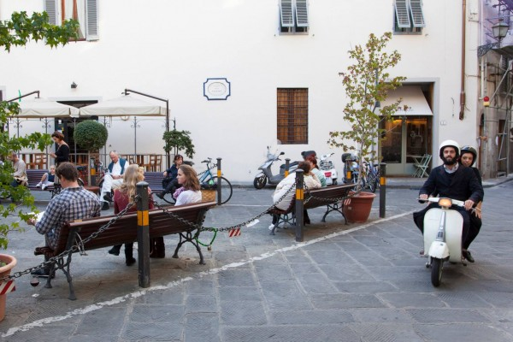
Quick links
- About Florence from Wikipedia
- City of Florence: Official Website
- Official Tourist Information
- Florence Guide
- Museums: buy tickets online
- Events and Culture in Florence & Tuscany
- Weather Forecast

