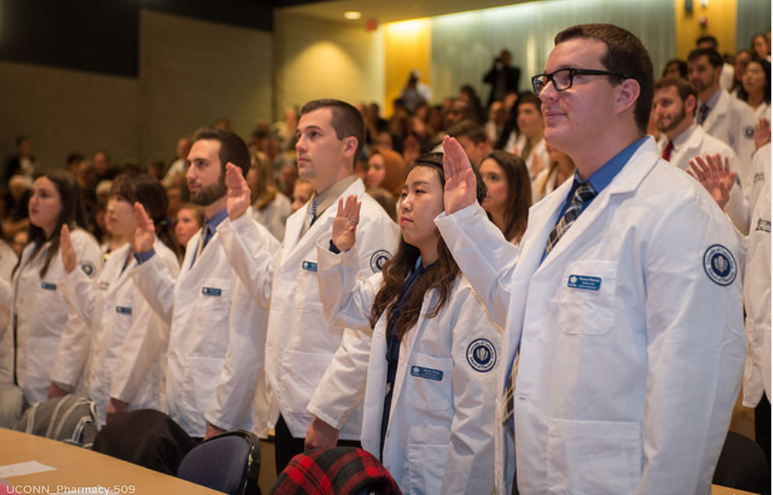

Student Handbook

**UConn School of Pharmacy**

**Student Handbook**

The Student Handbook is provided as a guide and resource to all students, staff and faculty at the UConn School of Pharmacy. The intent of this document is to provide you with a quick reference to some of the more frequently asked questions and not to be a compendium of all of our School’s policies and procedures.

This Student Handbook will replace all previous handbooks and apply to all UConn School of Pharmacy students effective with the start of the fall semester. Periodic updates to the Student Handbook will occur yearly, if not more frequently, to reflect any changes to the content of this document. This document will be posted electronically on the UConn School of Pharmacy web page and in our student HuskyCT site.

Our administration, faculty and staff at the UConn School of Pharmacy are committed to providing you with a supportive and caring learning environment. This handbook is one of many resources available to you as a student at the School of Pharmacy to assist you in achieving a successful academic career and preparing you for your future as a pharmacist.

Sincerely,

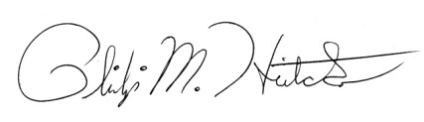

Philip M. Hritcko, Pharm.D., CACP, RPh.

Associate Dean for Admissions & Student Affairs

Associate Clinical Professor

**Table of Contents**

**Administration** Administrative Support Staff and Faculty Directory………………………………5  
 Pharmacy Library………………………………………………………………………….………5  
 Accreditation Status …………………………………………………………………….….…. 6

**Academic Affairs** Pharmacy Degree Program and W Courses...………………………….……..…….9  
 How to Request Professional Electives……………………………………….………..11

Curricular Tracks…………………...………………………………………………...............12

Dual Degree Professional Programs..……………………………………...………..….14

Honors and Research Programs…………..………………………………………………..15  
 Study Abroad…………………………………………………………………………………….…..15

My Creds & Core Comp MS.…………………………………………………………………..16  
 Evaluation of Teaching and Courses……………………………………………….……..16

ExamSoft®……………………………………………………………………………………….…….16

Core Elms……………………….……………………………………………………………..………16

Experiential Education…………………………………………………………………..………17

Calculator Policy…………………………………………………………………………..……....18

Requirement for Laptop/Tablet…………..………………………………………………..19

Recording Lectures……………………………..………….……………………………………..20

**Student Affairs**Advising and Course Registration……………………………………………………..……22

Transfer Credit and Course Waiver Policy.………………………………….……..….23

Grading Policy………………………………………………………….……………………………24

Missed Exam and Final Exam Policy………………………….………………….……….24

Technical Standards for Admission, Progression and Graduation…….……25

Policy on Academic Integrity…………………………………………….…………………..27

D Policy……………………………………………………………………….……………….……….31

Probation and Dismissal Policies….…………………………….……………....….…….31

Implementation of Academic/Technical Standards….…………………….……..31

Office of Pharmacy Professional Development……………………………….…….36

Preparation for Internships and Licensure…………………………………….………37

Student Lockers……………………………....……………………..……………………………39  
 Parking Policy……………………….………………………………………………………………39  
 Lost and Found...…………………...…………………………………..………………………..39  
 Student Lunch Room ………………………………………….……………….……………….39  
 Email Accounts…………………………………………………………………..…………………39

Organizing an Event………………………………………………………..…………………….40

Professional Student Programs……………………………………………….…..………..41

**Table of Contents (Continued)**

Lunch and Learn…………………………………………………………………………………..41  
Professional Conduct…………………………………………………………….…..…………42

Pharmacy Scholarships……………………………………………………………….………..43

**Student Affairs (Continued)**

Pharmacy Awards and Prizes……………………………………………………………….43

Financial Aid………………………………………………………………………………………..44

Student Representation on School Committees…….…..………………..……..44

Student Organizations…………………………………………………………………..…….46  
 Rho Chi Tutoring Program……………………………………………………………………52

**General Information**

Tuition and Fees…………………...……………………….……………………………….……54

Copier Use Policy……………………………………………..…………………………….…….54

Student Bulletin Boards………………………….………………………….…………………54  
 Logo Usage……………………………………………….……….…………….……………………54  
 Pharmacy Rooms…………………………………….……………………….…………………..54  
 AED Devices…………………………………………….………………………….………………..60  
 Fire Alarm……………………………………….………….……………………….……..…………60

**Pharmacy Support Staff and Faculty Directory**

A complete and up to date directory can be found on our website at: <https://pharmacy.uconn.edu/our-team/>

**Pharmacy Library**

The Pharmacy Library supports the information and research needs of the students, faculty, and alumni of the School of Pharmacy and related areas. The Pharmacy Library provides access to online and printcollections of books, journals and media related to research in our primary subject specialties.

Library services include reference assistance and library research instruction. General help with library use is provided by student assistants at the service desk. The pharmacy librarian provides more specific reference and research consultation. Formal library instruction sessions are provided upon request.

 Access to various databases, electronic reserve materials, and relevant internet resources is available on the Pharmacy Library and Hait Family Computer Laboratorypublic workstations. Databases include General Search, a discovery tool to locate relevant materials (books, journal articles, media, etc.); PubMed; Micromedex; Scopus; SciFinder Scholar, Chemical Abstracts; and International Pharmaceutical Abstracts. Assistance with information searching is available. Contacting the librarian via e-mail for an appointment is suggested.

Groups of two to six may reserve the group study rooms in the Pharmacy Library for periods of 2 hours.  Contact the service desk for further information.

Printing is available in the Pharmacy Library and on your laptop via HuskyPrint by using the One Card/Husky Bucks system.

 The Pharmacy Library is located on the second floor of the Pharmacy-Biology Building in room PBB 228.

**Staff:**

Sharon Giovenale, Pharmacy Librarian

Telephone: (860) 486-2218, Fax: (860) 486-4998

Email: sharon.giovenale@uconn.edu

Pharmacy Library Resource Web Page: http://rdl.lib.uconn.edu/subjects/1960

Library Research Guide: <http://classguides.lib.uconn.edu/pharmaceuticalscience>

**Hours During the Academic Term:**

Monday - Thursday, 8:30 A.M. – 10:00 P.M.

Friday, 8:30 A.M. – 5:00 P.M.

Saturday, 10:00 A.M. – 5:00 P.M.

Sunday, 1:00 P.M. – 9:00 P.M.

**Accreditation Status**

The University of Connecticut’s Doctor of Pharmacy program has been granted full accreditation by:

The Accreditation Council for Pharmacy Education (ACPE)

20 North Clark Street, Suite 2500

Chicago, IL 60602-5109

PHONE 312-664-3575; FAX 312-664-4652

<http://www.acpe-accredit.org/>

The school undergoes an accreditation self-study and site visit by this accrediting body every 8 years. Students are asked to be members of the different school committees for this self-study.

**Student Complaints Policy**

***Re: ACPE Standards***

ACPE has an obligation to assure itself that any institution which seeks or holds a pre-accreditation or accreditation status for its professional program(s) conducts its affairs with honesty and frankness. Complaints from other institutions, students, faculty, or the public against the School of Pharmacy at the University of Connecticut, including tuition and fee policies, and as related to ACPE standards, policies or procedures, shall be placed in writing in detail by the complainant and submitted to the ACPE office at the following email addresses:

csinfo@acpe-accredit.org (regarding a professional degree program)  
ceinfo@acpe-accredit.org (regarding a continuing education provider)

Additional detail of the ACPE policy can be found at http://www.acpe-accredit.org/complaints/default.asp

***Re: School of Pharmacy Policies and Procedures***

Student complaints of policies, procedures and standards shall be submitted in writing (signed and dated) to the Office of Admissions and Student Affairs for response. Requests for confidentiality shall be respected to the extent any such information is not necessary for the resolution of the complaint; anonymous complaints will not be considered. To submit a complaint, the student should follow the procedure detailed below.

**Procedure for Didactic Classes/Labs**

1. The student should write a letter detailing the complaint to the teaching assistant, instructor, or course coordinator depending on the nature of the concern. The letter must include local and permanent address information, contact information, a detailed account of the complaint and resolution or relief being sought. The instructor will respond within 10 business days.

2.  If the complaint cannot be resolved at this level, it should be submitted to the associate dean for admissions and student affairs in the School of Pharmacy in a written letter as described above.

3.  If the associate dean for admissions and student affairs is unable to resolve the issue, he/she will form an ad hoc committee of three faculty members, at least one member from each department (i.e., Pharmacy Practice and Pharmaceutical Sciences), and ask the committee to review the complaint and make a recommendation.

4.  The student will receive a written response within 30 days.

5.  If the student wishes to appeal the decision, he/she may appeal to the dean of the School of Pharmacy within 10 business days.

6.  The dean makes a decision and informs the student within 10 business days.

7.  The decision of the dean is final.

8.  If there is a conflict of interest between either the associate dean for admissions and student affairs or dean and the student’s complaint, then resolution of the decision will be made by the UConn Dean of Students Office.

9.  The original written complaint and written response to the student and, if applicable, the letter of appeal and written decision of the dean shall be kept on file in the Office of the Admissions and Student Affairs. A photocopy will also be placed in the file of the student.

**Procedure for Experiential Education**

For complaints pertaining to experiential education (IPPE or APPE), students should refer to the Office of Experiential Education Professional Experience Manual in Core Elms (Document Library tab).

Academic Affairs

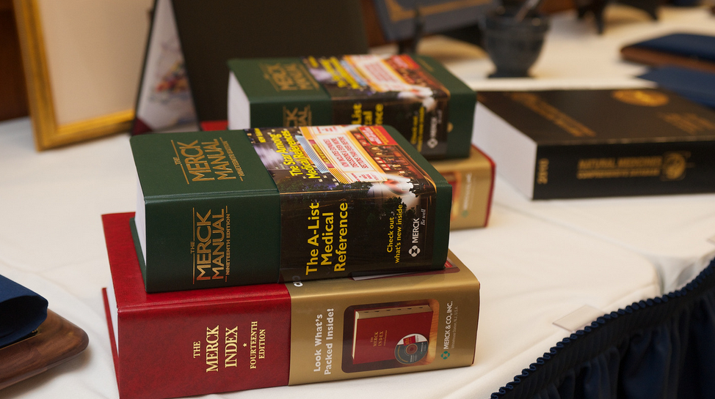

**The Doctor of Pharmacy Degree Program**

Students are admitted to the pharmacy studies degree program after completion of the two-year pre-pharmacy program (64 credits). Upon successful completion of the first 2 years of the Doctor of Pharmacy degree program (137 total credits), a Bachelors of Science with a major in pharmacy studies (BS Pharmacy Studies) is conferred.

**W Courses**

Students who have not taken their non-pharmacy W course prior to entering the School of Pharmacy, must complete this course prior to starting the P2 year. PHRX 4001W (3 credits) will be open only to students in their P2 year. A listing of these courses will be provided in the spring of P1 year prior to registration for the P2 year. There will be a total of six sections offered over the fall semester and spring semesters. Enrollment is limited to 19 students per section.

**General Education Requirements**

|  |  |  |
| --- | --- | --- |
| **First Professional Year - Fall Semester 20 Credits** | | |
| PHRX 3000 | Cellular Biology | 2 cr |
| PHRX 3002 | Foundations in Bioorganic Chemistry | 3 cr |
| PHRX 3006 | Drug Information I | 1 cr |
| PHRX 3008 | Pharmacy Communications | 3 cr |
| PHRX 3009 | Principles of Drug Action | 3 cr |
| PHRX 3030 | Pharmacokinetics / Biopharmaceutics | 3 cr |
| PHRX 3050 | Public Health & Healthcare Policy | 3 cr |
| PHRX 3060 | Pharmacy Skills Development I | 2 cr |
| **First Professional Year - Spring Semester 17 Credits** | | |
| PHRX 3001 | Immunology | 2 cr |
| PHRX 3003 | Nutrition | 2 cr |
| PHRX 3007 | Drug Information II | 2 cr |
| PHRX 3031 | Foundations in Pharmaceutics I | 4 cr |
| PHRX 3032 | Dosage Forms Preparation Laboratory | 1 cr |
| PHRX 3040 | Neurology Module | 4 cr |
| PHRX 3065 | Pharmacy Skills Development II | 2 cr |

UConn’s general education requirements are listed in the Academic Regulations section of the *University of Connecticut General Catalog*. You must have all university general education requirements completed by the end of the second year of the professional program to be eligible to graduate with the Bachelor of Science in Pharmacy Studies and continue with the final 2 years of the Doctor of Pharmacy degree program.   
 **1st Professional Year 2nd Professional Year**

|  |  |  |
| --- | --- | --- |
| **Second Professional Year - Fall Semester 19 Credits** | | |
| PHRX 4030 | Foundations in Pharmaceutics II | 3 cr |
| PHRX 4031 | Dosage Forms Preparation Laboratory II | 1 cr |
| PHRX 4040 | Psychiatry Module | 5 cr |
| PHRX 4041 | Immunology Module | 2 cr |
| PHRX 4050 | Pharmacy Practice Management | 2 cr |
| PHRX 4063 | Pharmacy Skills Development III | 3 cr |
|  | Professional Electives* | 3 cr |
| **Second Professional Year - Spring Semester 17 Credits** | | |
| PHRX 4000 | Pharmacoeconomics | 1 cr |
| PHRX 4001W | Current Topics in Pharmacy | 3 cr |
| PHRX 4042 | Gastroenterology Module | 2 cr |
| PHRX 4043 | Endocrine Module | 3 cr |
| PHRX 4044 | Dermatology Module | 1 cr |
| PHRX 4051 | Pharmacy Law & Ethics | 2 cr |
| PHRX 4063 | Pharmacy Skills Development IV | 2 cr |
|  | Professional Electives * | 3 cr |
| *These courses must be completed by the end of the second professional year to complete 137 credits for graduation with a Bachelor of Science in Pharmacy Studies. | | |

**3rd Professional Year**

|  |  |  |
| --- | --- | --- |
| **FOURTH PROFESSIONAL YEAR**  **Professional Experience Electives, Choose 5 (one month each) 20 credits.** At least two of the elective courses must involve direct patient care. * = Direct Patient Care (other rotations may be available any given year) | | |
| PHRX 5104 | Cardiology* | 4 cr |
| PHRX 5105 | Infectious Disease* | 4 cr |
| PHRX 5106 | Oncology* | 4 cr |
| PHRX 5107 | Psychiatry* | 4 cr |
| PHRX 5108 | Pediatrics* | 4 cr |
| PHRX 5109 | Geriatrics* | 4 cr |
| PHRX 5110 | Community Practice II* | 4 cr |
| PHRX 5111 | Critical Care* | 4 cr |
| PHRX 5114 | Emergency Medicine | 4 cr |
| PHRX 5115 | Home Health Care | 4 cr |
| PHRX 5116 | Institutional Pharmacy II | 4 cr |
| PHRX 5117 | Industry | 4 cr |
| PHRX 5118 | Managed Care | 4 cr |
| PHRX 5119 | Nuclear Pharmacy | 4 cr |
| PHRX 5122 | Skilled Care Nursing Facility | 4 cr |
| PHRX 5123 | Surgery* | 4 cr |
| PHRX 5124 | General Medicine-II* | 4 cr |
| PHRX 5125 | Ambulatory Care II* | 4 cr |
| PHRX 5126 | Anticoagulation* | 4 cr |
| PHRX 5128 | Hospice* | 4 cr |
| PHRX 5133 | Clinical Toxicology | 4 cr |
| PHRX 5135 | Investigational Drugs | 4 cr |
| PHRX 5136 | Drug Information | 4 cr |
| PHRX 5137 | Pediatrics II* | 4 cr |
| PHRX 5138 | Industry II | 4 cr |
| PHRX 5139 | Pharmacy Association | 4 cr |
| PHRX 5140 | FDA | 4 cr |
| PHRX 5141 | Oncology II* | 4 cr |
| PHRX 5142 | Diabetes Care II* | 4 cr |
| PHRX 5143 | Psychiatry II* | 4 cr |
| PHRX 5146 | Managed Care II | 4 cr |
| PHRX 5147 | International Pharmacy Practice | 4 cr |
| PHRX 5149 | Critical Care II* | 4 cr |
| PHRX 5150 | Pain Management* | 4 cr |
| PHRX 5152 | Medication Safety | 4 cr |
| PHRX 5153 | Academia | 4 cr |
| PHRX 5154 | Organ Transplantation | 4 cr |
| PHRX 5155 | International Pharmacy Practice II | 4 cr |
| PHRX 5157 | Community Practice III | 4 cr |
| PHRX 5161 | Pharmacy Informatics | 4 cr |
| PHRX 5164 | Infectious Disease II | 4 cr |
| PHRX 5165 | Pharmacy Management | 4 cr |
| PHRX 5166 | Outcomes Research | 4 cr |
| PHRX 5167 | Urban Service Track | 4 cr |
| PHRX 5169 | Professional Experience in Pharmacy Leadership | 4 cr. |
| PHRX 5195 | Special Topics | 4 cr |
| PHRX 5199 | Research | 4 cr |

|  |  |  |
| --- | --- | --- |
| **Third Professional Year - Fall Semester 19 Credits** | | |
| PHRX 5040 | Cardiovascular Module | 4 cr |
| PHRX 5041 | Renal Module | 2 cr |
| PHRX 5042 | Respiratory Module | 2 cr |
| PHRX 5046 | Clinical Toxicology | 2 cr |
| PHRX 5060 | Pharmacy Skills Development V | 3 cr |
| PHRX 5062 | Pharmacy Law and Regulatory Affairs | 3 cr |
|  | Professional Electives** | 3 cr |
| **Third Professional Year - Spring Semester 19 Credits** | | |
| PHRX 5043 | Infectious Disease Module | 4 cr |
| PHRX 5044 | Hematology / Oncology Module | 3 cr |
| PHRX 5045 | Special Populations | 4 cr |
| PHRX 5048 | Patient Assessment | 2 cr |
| PHRX 5065 | Pharmacy Skills Development VI | 2 cr |
|  | Professional Electives** | 3 cr |
| *\*\* These professional electives can be taken prior to the 3rd professional year and still count toward the 12 professional electives needed. 210 total credits are necessary for the Pharm.D. degree.* | | |

**4th Professional Year**

To be eligible for the fourth professional year courses, students must have completed the BS in Pharmacy Studies and the first year of the Pharm.D. Program.

The required rotating professional experiences are one

month each for a total of 16 credits (1 credit = 40 hours).

**Exemption and Substitution.** Students who desire to be

excused from any of the following requirements or to

substitute other courses for those prescribed, should consult the associate dean for admissions and student affairs of the School of Pharmacy to request

approval.

|  |  |  |
| --- | --- | --- |
| **Fourth Professional Year Choices Continued** | | |
| PHRX 5159 | Burn Care | 4 cr |
| PHRX 5160 | Academia II | 4 cr |
| PHRX 5161 | Pharmacy Informatics | 4 cr |
| PHRX 5162 | Hospital Administration | 4 cr |
| PHRX 5163 | Neurology | 4 cr |
| PHRX 5164 | Infectious Disease II | 4 cr |
| PHRX 5165 | Pharmacy Management | 4 cr |
| PHRX 5166 | Outcomes Research | 4 cr |
| PHRX 5167 | Urban Service Track | 4 cr |
| PHRX 5168 | Pediatric Infectious Disease | 4 cr |
| PHRX 5169 | Professional Experience in Pharmacy Leadership | 4 cr. |
| PHRX 5172 | Institution Based Clinical Practice | 4 cr |
| PHRX 5195 | Special Topics | 4 cr |
| PHRX 5199 | Clinical Research | 4 cr |

**Professional Elective Guidelines**

Students are required to complete 12 professional elective credits for the Doctor of Pharmacy program. The following guidelines must be followed when considering electives:

**General Requirements for Professional Electives**

* Advisors will work with students to develop a professional elective “plan” that will be forwarded to the UConn Registrar by the Office of Admissions and Student Affairs.
* Any combination of approved courses offered by the school or outside the school can be used to fulfill the 12 professional elective credits
* These 12 credits of professional electives must be taken for a grade. Electives beyond these 12 may be taken pass/fail.
* Courses used to fulfill a general education requirement (such as Content Areas and W courses) may not be counted as a professional elective.
* Pharmacy independent study credits (including Future Pharmacy Leaders and FYE Mentor) may be used to fulfill elective requirements.
* If a course is taken that is ineligible for pharmacy students  (e.g. PHAR 1001 or PHAR 1000) then it cannot be used.
* If uncertain as to the eligibility of a course toward professional electives, please consult the associate dean for academic affairs.

**Specific Requirements Pertaining to Non-Pharmacy Courses**

* Courses taken in fulfillment of the Pharm.D./MBA or Pharm.D./MPH may be used to fulfill the 12 credits of professional electives.
* **OR**
* Courses up to 6 credits taken in fulfillment of a second major or a minor (current or recent past) could be used.  A time limit may apply.
* **OR**
* A course on the approved list taken prior to entering the School of Pharmacy, may count toward professional electives (limit of 3 credits).
* You may NOT count credits from a second major or minor PLUS a pre-pharmacy course

**Needs Approval of Associate Dean for Academic Affairs**

* To use a course outside the school that is not on the provided list, submit a request to the associate dean for academic affairs for approval.
* Credits from the study abroad experience may be used with approval from the associate dean for academic affairs.
* Foreign language credits beyond the 1 year of required foreign language may be used with approval from the associate dean for academic affairs.
* Consult the associate dean for academic affairs to determine eligibility of graduate coursework.
* Online courses or community college courses taken may be acceptable with the approval of both the associate dean for academic affairs in the School of Pharmacy and UConn Transfer Admissions.

**Program Enhancements**

A number of optional program enhancements are available to students who wish augment their pharmacy education or increase their knowledge and skills in a particular area of specialization.

**Curricular Track Options**

The goal of the curricular tracks is to provide students who have a passion for an area of pharmacy the option to develop and apply advanced skills in that area. The designation of “Track Scholar” will be given to students who are accepted into and complete all of the requirements of the track. Currently, Urban Service Track, Pediatric Pharmacy Track, LEADERS Track and the Pharmaceutical Sciences Track are available.

Each track delineates the application process as well as the minimum entry and graduation requirements for the students. Students may apply to more than one track, but can participate in only one track. Please contact the associate dean for admissions and student affairs for more information.

The following represent minimum requirements; specifics may be found within the description of each track.

* Completion of an application and acceptance into a track program.
* Minimum GPA for admittance.
* Entry into a track program during P2 or by the beginning of P3 year.
* Four credits of elective didactic / independent study course work that is defined by the track.
* The equivalent of up to two credits of introductory applied activities. For clinically-related concentrations, these are typically accomplished during IPPEs. For research-based concentrations, these would likely be introductory lab skills.
* Four credits of an independent research project in the track concentration.
* Four credits of advanced application within the area of track concentration. For clinically-related concentrations, this is an advanced APPE within that concentration. For research based concentrations, this would be defined by the track (e.g. advanced coursework or advanced research).
* Presentation of final projects during the year in which the track is completed.

*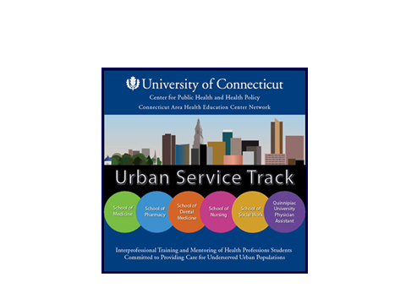Courses taken in fulfillment of a track can be used toward professional electives and can be completed in addition to any honors activities.*  
  
 **Urban Service Track Program**

Dr. Devra Dang - ddang@stfranciscare.org

* A collaboration between the UConn’s Schools of Pharmacy, Dental Medicine, Medicine, Nursing and Social Work, the Quinnipiac University’s Physician Assistant Program, and the community.
* Urban Service Track scholars participate in activities to understand health literacy, population health, inter-professional teamwork and leadership, professional and ethical conduct, health policy and advocacy.  Focus on vulnerable populations which include the homeless, children, elderly, and immigrants.

**Leaders Track Program**

* **L**eadership through **E**ngagement, **A**dvocacy, **D**edication, **E**ducation, **R**esearch, and **S**ervice.
* The Pharmacy LEADERS Track is intended to identify and develop the next generation of pharmacy leaders by:
* Increasing student awareness of current issues in pharmacy practice and care.
* Increasing awareness of leadership challenges / opportunities in pharmacy
* Exploring individual leadership styles and strengths.
* Enhancing student-faculty interaction outside of class.
* Providing students with the opportunity to actively engage and positively influence the university, community, and beyond.

**Pediatric Pharmacy Track**

Dr. Jennifer Girotto – jgirotto@connecticutchildrens.org

* This track is designed to provide the pharmacy student with tools to help them succeed as pediatric clinical practitioners.
* Students will have exposure to a wide-range of pediatric experiences throughout their time in the Pharm.D. program.

**Pharmaceutical Sciences Track**

Dr. Andrew Wiemer – andrew.wiemer@uconn.edu

* This track will provide pharmacy students with greater exposure to the pharmaceutical sciences and related research
* The track is designed to help students that are: 1.) considering working as a pharmacist for a pharmaceutical company, or 2.) planning to pursue a joint Pharm.D./Ph.D. degree, or 3.) enjoy science/have a science minor.

**Dual Degree Professional Programs**

The dual degree programs offer a small number of highly motivated students who seek to combine pharmacy education suitable for professional licensure with synergist areas of advanced study.

Pharm.D./Ph.D. Program

This program provides advanced research-based training in the Pharmaceutical Sciences. Students completing this program will earn consecutive dual degrees, the Pharm.D. followed by the Ph.D. Students in this track are afforded early acceptance into the Ph.D. program and, if they successfully complete the Pharm.D. curriculum, a modified graduate curriculum which will shorten the total time required to complete both degrees. Students must meet the admission requirements of both programs and apply to the Ph.D. program in the spring semester of the P2 year as they complete the Bachelor of Science in pharmacy studies.

Pharm.D./MBA Degree Program

The joint Pharm.D./MBA program combines pharmacy education with business managerial knowledge and skills. After completing the first 2 years of study in the School of Pharmacy, students step away from the school for one year to complete coursework in the MBA Program. Students then return to the School of Pharmacy to complete the final 2 years of the Pharm.D. degree. Both pharmacy and business courses are taken during the P3 year. Students must meet the admission requirements of both programs and apply to the MBA Program in the spring semester of the P2 year as they complete the

Bachelor of Science in pharmacy studies. Both the Pharm.D. and the MBA will be conferred simultaneously after the program requirements have been successfully met.

Pharm.D./MPH Degree Program

The joint Pharm.D./MPH program combines pharmacy education with public health and its administration, public health law, environmental health, health literacy, and urban service. After completing the first 2 years of study in the School of Pharmacy, students step away from the school for one year to complete coursework in the MPH . Students then return to the School of Pharmacy to complete the final 2 years of the Pharm.D. degree. Both pharmacy and public health courses are taken during the P3 year. Students must meet the admission requirements of both programs and apply to the MPH Program in the spring semester of the P2 year as they complete the Bachelor of Science in pharmacy studies. Both the Pharm.D. and the MPH will be conferred simultaneously after the program requirements have been successfully met.

**Honors and Research Programs**

Students can continue in the UConn Honors Program or begin the UConn Honors Program once admitted to pharmacy school. Students must maintain a cumulative GPA of 3.4 and complete the required number of honors courses to remain in the Honors Program. Students may graduate with honors as with their bachelor’s degree (either in pharmacy studies or another UConn major) or with honors as a Pharm.D. degree recipient, but generally not with both degrees. Students should contact Dr. Brian Aneskievich, the honors advisor, for more information regarding criteria and the pharmacy courses that are eligible for honors credit.

The pharmacy research program is an enrichment opportunity for students who wish to explore a challenging educational experience outside of the traditional pharmacy curriculum. The goals of the program are to foster independent thinking, student-faculty interactions, and to clarify potential career options.  
  
The program offers students the opportunity to develop unique abilities and leadership skills that are useful in future employment and post-graduate settings. Part of the value of the program is also the intellectual growth experienced by participating in a research project that explores topics beyond the limited exposure available in the traditional curriculum. The research project helps to integrate knowledge gained in the classroom. The program affords students the opportunity to present the results of their work in different settings within the school (e.g., group research meetings, seminars, Pharmacy Research Seminar, and the annual University of Connecticut Pharmacy Research Symposium), at the annual University of Connecticut Frontiers in Undergraduate Research program, and at regional professional meetings.  
  
Any pharmacy student with a GPA above 2.8 is eligible to participate in an Independent Study Research Project. Students are not expected to develop an original research idea. Students work with a research mentor on the development and execution of the project.   
  
Students may apply to the UConn Honors Program and/or the University Scholars Program.

**Global Opportunities**

**Study Abroad**

UConn offers many study abroad opportunities including Traditional Chinese Medicine which was developed by the School of Pharmacy. This program, typically offered in May, provides students with the opportunity to study Traditional Chinese Medicine in Beijing, China. It includes the history of and the philosophy behind traditional Chinese medicine and provides an overview of the resources available (including sources, chemistry, analysis, and formulation into medicine.) The program includes formal lectures, discussions and field trips. Field trips may include field collection of medicinal plants, as well as visits to traditional Chinese medicine manufacturers and traditional Chinese medicine departments of hospitals. Students will also take 28 hours of basic Mandarin. Several cultural activities are planned as well. School of Pharmacy faculty members accompany students on this experience.

This experience is designed as a 6 credit course (2 credits of the language and 4 credits for the Traditional Chinese Medicine course). Students must be at least a junior in college; be a major in pharmacy or another science and have a minimum 3.0 GPA.

**Practice Experiences**

Students may work with the Office of Experiential Education to arrange global practice experiences. The school has a memorandum of understanding for global exchange with Taiwan Medical University (TMU). Other international experiences may be available but you need to discuss your interest with the Director of Experiential Education.

CORE ELMS & CORE MyCred

CORE ELMS is our rotation management system. This system allows you to maximize your learning experience as it will aid you in your placements through intelligent algorithms and tools to research sites, select sites and prioritize site selections. The system eases administrative tasks faced by you once you are in your placements such as submitting hours of your experience, completing evaluations, encounters, workbooks, etc.

MyCred is a self-curated portfolio designed to manage and present your educational and professional achievements. This is beneficial to the preceptors at your experience sites as it provides them the ability to see your educational and professional achievements.

**Evaluation of Teaching and Courses**

Pharmacy professional program students participate in two evaluation programs during the academic year. Both of these online evaluation programs are conducted by the Office of Instructional Research. They may take place in or out of the classroom.

* Student Evaluation of Faculty Teaching, schedule at the conclusion of a series of lectures and at least on posted exam

Focus: Individual instructors

Reviewed By: Dean, Department Head and instructor(s)

**Exam Soft**Many exams will be given through ExamSoft. It is a computer based software used all over the country for a variety of disciplines such as: medical, law, allied health, dental, nursing, veterinary, and pharmacy. It allows students to become more comfortable with computer based testing to prepare for exams such as the Pharmacy Curriculum Outcomes Assessment (PCOA) and the North American Pharmacist Licensure Examination (NAPLEX). Curriculum exams given on ExamSoft will be through a computer application, Examplify. Each student must download Examplify on the computer they plan to use for testing. You will find the download at examsoft.com/uconnpharm. Exam questions will be either multiple choice, true/false, fill in the blank, or essay format. Students will be given instructions on how to prepare before each exam from their professor. Grades will be accessed through Examsoft.com/uconnpharm and lms.uconn.edu. If there are any specific questions regarding ExamSoft or Examplify, please contact Judy Frankel at [Judith.frankel@uconn.edu](mailto:Judith.frankel@uconn.edu).

**Experiential Education**

After countless hours dedicated to lectures, labs, study sessions and exams, it is time to put your skills to the test of in the real world. Regardless of the number of simulated patient experiences, multiple-choice, fill-in the blank or matching questions you have successfully completed, no classroom activity can be a substitute for the hands-on training that the introductory and advanced pharmacy practice experiences (IPPEs and APPEs) can provide. Your rotations will likely be one of the first times you can use what you have learned in pharmacy school to make a significant impact on your patient’s health. Often, this transition comes with some degree of difficulty. You will be required to make the leap from hypothetical situations and abstract concepts to addressing real drug-related problems in situations much more complex than anything you can find in a textbook.

The School of Pharmacy Office of Experiential Education oversees the pharmacy practice experience programs which include Introductory Pharmacy Practice Experiences (IPPE) and Advanced Pharmacy Practice Experiences (APPE). IPPEs occur during the first through third professional years (P1 – P3) and APPEs are scheduled during the fourth professional year (P4). Students are encouraged to engage the Office of Experiential Education for assistance, advice, and counsel regarding their experiential learning placements.

The Office of Experiential Education engages state, regional, and national/international preceptors/practice sites to support our pharmacy practice experiences for students as they progress through each of the professional years of the Doctor of Pharmacy (Pharm.D) professional program. Many of these sites are also the practice sites for a number of the school’s faculty. Additionally, the Office of Experiential Education is responsible for quality assurance and oversight of all pharmacy practice experiences and to ensure that desired learning outcomes are achieved. The office also serves as a resource and support for all preceptors participating in our experiential programs and provides ongoing preceptor development programming. To get more information about our School’s experiential program please see the “Professional Experience Program Manual” located in the Core Elms - “Document Library” in the “Manuals” folder.

**Clinical Placement Software System**

The Office of Experiential Education engages two important tools provided by CORE ELMS to assist with our experiential learning program: 1.) Core Elms assists with the management of experiential site placements and evaluations and 2.) Core ePortfoilio (MyCred) assists students with the development and presentation of their individual professional portfolio to share with prospective preceptors. During their time at the School of Pharmacy, students will use Core Elms to help them manage the many experiential learning opportunities in which they will participate. Students will be encouraged to use and update MyCred to provide their preceptors with an accurate portfolio of experiences and accomplishments. These two tools operate within the same framework allowing administrators, faculty, preceptors, and students to go seamlessly between the various systems and to share and store information.

Students are required to keep accurate and up to date information recorded within both Core Elms and MyCred.

**Out of Network Pharmacy Practice Sites and the Professional Experience Program:**

Our School of Pharmacy maintains a robust network of practice sites largely in Connecticut with some sites also located in nearby states. All of these sites maintain active affiliation agreements with us. We communicate with these sites regularly to gather information about availability, credentialing and so on.

Students desiring a rotation at a site that is not affiliated with the Professional Experience Program must submit a Site Prospector form, available on Core Elms. The Director of Experiential Learning, or their designate, will evaluate all new sites before being approved for the experiential education program to ensure they meet our quality standards.

**Complio**

The University has contracted with Complio to complete screenings on UConn students.   Complio is used for immunization and compliance tracking.  Do be aware that there are costs involved with the screening of requirements which is the student’s responsibility.   You must be in compliance with your immunizations in order to be able to participate in rotations.  Some of our sites also have additional requirements such as drug screenings, background checks, and fingerprinting which you will be responsible for ordering and the costs of the screenings is the student’s responsibility.

**Contacts for Experiential Education:**

Director of Experiential Learning

Jill Fitzgerald 860-486-3151 PBB 341 [jill.fitzgerald@uconn.edu](mailto:jill.fitzgerald@uconn.edu)

Assistant Director of Experiential Education  
Mary Ann Phaneuf 860-486-2999 PBB 343 [mary.phaneuf@uconn.edu](mailto:mary.phaneuf@uconn.edu)

Experiential Education Program Assistant

Joshlyn Lucas-Nash 860-486-5848 PBB 3rd Floor [joshlyn.lucas-nash@uconn.edu](mailto:joshlyn.lucas-nash@uconn.edu)

Field Coordinator  
Mary Morytko 860-450-6188, PBB 340 mary.morytko@uconn.edu

**Calculator Policy**

Students are required to use the School of Pharmacy calculators during exams that require them. Although these calculators cannot be checked out by students, students may familiarize themselves with the calculators in the Office of the Admissions and Student Affairs prior to the exam.

The calculators used are Texas Instruments TI-30X IIS.

**Required Laptop/Tablet**

All incoming P1s will be required to have a laptop or tablet that meet the minimum standards outlined below, allowing for (at minimum) ExamSoft and MyDispense software to be used across the curriculum (over the course of the next 3 years).  The school will work with HuskyTech and/or the CoOp to identify what is best as far as purchasing methods and IT support for our students.

**Minimum requirements for PC / Mac laptop or Tablet requirement for pharmacy students**  
Minimum suggested requirements (PC or Mac):  
Hard drive:  256GB solid state drive (or larger)  
Memory: 8GB (or more)  
Operating System:  Windows 7 Professional or newer (64-bit preferred); OS X Mavericks or newer  
Webcam  
Wireless 802.11 a/b/g/n/ac WiFi capability  
Bluetooth capability  
Minimum software requirements [all available for download thru: huskytech.uconn.edu]:  
Microsoft Office 2010 or newer (PC); Microsoft Office 2011 (Mac) - must have Word, Excel, PowerPoint at minimum

Battery with at least 4hr duration  
Adobe Reader XI (or newer)  
Internet Explorer  
Firefox or Chrome [must have one or the other to run ExamSoft; Internet Explorer is not a preferred browser for it]  
Microsoft Security Essentials (PC) or Avira (Mac)  
Shockwave from <http://www.adobe.com>  
Real Player from <http://www.realnetworks.com>  
Windows Media Player from <http://www.microsoft.com>  
Adobe Flash Player from <http://www.adobe.com/products/flashplayer>  
Java

**Surface Pro 1, 2 & 3 (Surface RT tablets are not supported) for pharmacy students**  
  *   External Keyboard (USB or Bluetooth) required. Bluetooth keyboards must be paired prior to launching exam.  
  *   Hard Drive: Minimum of 1GB available space.  
  *   Adobe Reader XI is required for exams containing PDF attachments.  
  *   Internet connection for SofTest Download, Registration, Exam Download and Upload.  
  *   Screen Resolution must be 1920x1080.

* Battery with at least 4hr duration  
  *   Administrator level account permissions.

* Microsoft Office suite 2010 or newer (as outlined above under laptops)

* Firefox or Chrome [must have one or the other to run ExamSoft; Internet Explorer is not a preferred browser for it.  
**iPad Requirements**  *   Hardware = iPad 2, 3, 4, 5 and iPad Mini  
  *   Operating System = iOS 6, iOS 7 and iOS 8. Only genuine versions of iOS are supported.  
  *   500 MB of free space required to commence an exam  
  *   iPad must not be Jailbroken

* Battery with at least 4hr duration  
*   To receive support, you must be able to connect the iPad to a computer with iTunes and IExplorer installed  
  *   Internet connection for SofTest Download, Registration, Exam Download and Upload.  
  *   In order to take an exam using SofTest-M, your institution must first enable this product and create exams that are compatible with your iPad.

* External Keyboard, paired prior to launching the exam

* Microsoft Office suite 2010 or newer (as outlined above under laptops)

**Policy on Recording Lectures**

Students must ask permission from the instructor or teaching assistant to record (audio or video) lectures for either personal use and/or distribution to other members of the class. Failure to receive permission constitutes a violation of the University Student Conduct Code. “Academic misconduct includes, but is not limited to, providing or receiving assistance in a manner not authorized by the instructor in the creation of work to be submitted for academic evaluation (e.g., papers, projects, and examinations...).” (Please see Appendix A in the Student Conduct Code.)

If an instructor grants permission, recordings can be provided only to members of the class and at no charge.

Student

Affairs

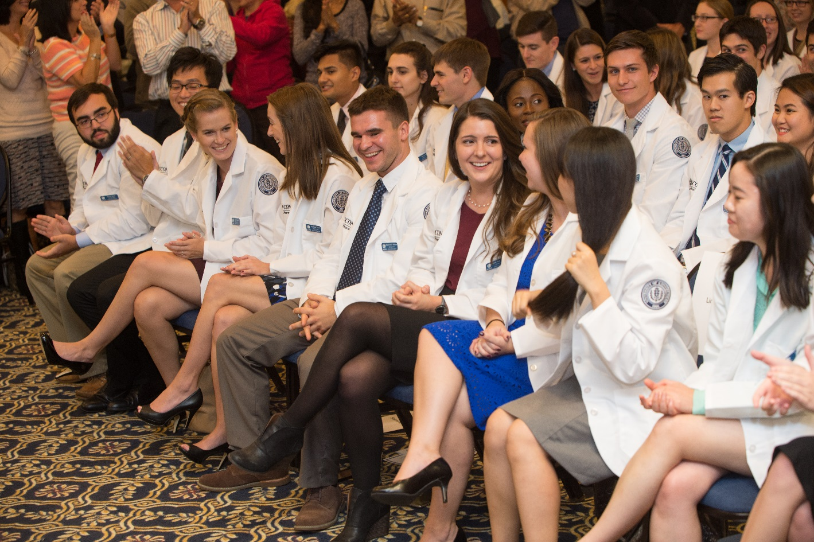

**Advising and Course Registration**

Academic advising is a service provided to assist students' progress toward meeting their academic objectives and completing their degree requirements.

The function of advising is recognized as an integral part of the university's educational mission. Contact on an individual basis with an academic advisor is an important means of identifying the needs of individual students. Although students are assigned to advisors, it is the responsibility of the student to know and to follow the regulations of both UConn and the School of Pharmacy and to plan and carry out the required Pharm.D. plan of study and the degree requirements of the both the university and school.

The Office of Admissions & Student Affairs coordinates the advising activities of P1-P3 advising teams. A team of four advisors is assigned to each class and each student is assigned to a specific advisor within the team. The team will serve as advisors to their assigned class throughout the first 3 years of the professional program.While students are assigned to a specific advisor in the appropriate team, the other members of that team serve as back-up advisors when necessary.

Incoming students are advised for the first 2 months by the associate dean for admissions and student affairs and director of student support & learning development and then are assigned to a faculty advisor prior to the first registration period. In this way, issues regarding transfer courses, substitutions, and waivers may be resolved. The Director of Student Support remains secondary advisor to all PharmD students to ensure that University and Program requirements are met for both BS and PharmD graduation Honors students are advised by the honors advisor for the School of Pharmacy, Dr. Brian Aneskievich. Students at academic risk, regardless of their year in pharmacy school, may be advised by director of student support and learning development.

The director and assistant director of experiential education, Dr. Jill Fitzgerald and Mary Ann Phaneuf, advise rising and current P4 students.

**Process**

Advising, in general, is conducted during the 2 weeks just prior to university registration (e.g. the second and third week of October; the first and second week of March). Students should either sign up for an appointment with their advisor by going to <http://advapp.uconn.edu/> or contact their advisor by email. If your advisor is unavailable, contact another advisor in the team for your class or the Office of Admissions and Student Affairs to be advised and have your bar lifted. Students in the spring of their P3 year should contact Dr. Jill Fitzgerald or Mary Ann Phaneuf instead of their normal advisor to sign up for rotations.

**Faculty Advisors**

A list of faculty advisors and their student advisees is distributed by email. All Honors Program students are advised by Dr. Brian Aneskievich.

Although your program of study for pharmacy is clearly defined, there are some less restrictive professional elective courses available. Students may want to take these additional credits to focus on a particular area of interest or develop a research program. Students should also ensure that they have completed all university general education requirements (content areas and non-major W course) by the end of their P2 year.

|  |  |  |
| --- | --- | --- |
| **Class of 2023 Advising Team** | **Office** | **Email Address** |
| Dr. Andrea Hubbard | 533 | [andrea.hubbard@uconn.edu](mailto:andrea.hubbard@uconn.edu) |
| Dr. Marcy Balunas | 630 | [marcy.balunas@uconn.edu](mailto:Marcy.balunas@uconn.edu) |
| Dr. Fei Wang | 342 | [Fei.wang@uconn.edu](mailto:Fei.wang@uconn.edu) |
| Dr. Marissa Salvo | 342 | [marissa.salvo@uconn.edu](mailto:Marissa.Salvo@uconn.edu) |
| **Class of 2022 Advising Team** | **Office** | **Email Address** |
| Dr. Jennifer Girotto | 346 | [jgirotto@ccmckids.org](mailto:JGIROTTO@ccmckids.org) |
| Dr. Raman Bahal | 528 | [Raman.bahal@uconn.edu](mailto:Raman.bahal@uconn.edu) |
| Dr. Lisa Holle | 342 | [lisa.holle@uconn.edu](mailto:Lisa.Holle@uconn.edu) |
| Dr. Adrian Hernandez-Diaz | 340 | [adrian.hernandez-diaz@uconn.edu](mailto:adrian.hernandez-diaz@uconn.edu) |
| **Class of 2021 Advising Team** | **Office** | **Email Address** |
| Dr. Bodhisattwa Chaudhuri | 430 | [bodhi.chaudhuri@uconn.edu](mailto:Bodhi.Chaudhuri@UConn.edu) |
| Dr. Kyle Hadden | 628 | [kyle.hadden@uconn.edu](mailto:Kyle.Hadden@uconn.edu) |
| Dr. William Baker | 342 | [william.baker_jr@uconn.edu](mailto:WILLIAM.BAKER_JR@uconn.edu) |
| Dr. Stephanie Gernant | 428 | [stephanie.gernant@uconn.edu](mailto:stephanie.gernant@uconn.edu) |
| **Honors Advisor** | **Office** | **Email Address** |
| Dr. Brian Aneskievich | 536 | [brian.aneskievich@uconn.edu](mailto:Brian.Aneskievich@uconn.edu) |

**Transfer Credit and Course Waiver Policy**

Any courses taken at other institutions (i.e. general education requirements, professional electives) must be approved by the Office of Admissions and Student Affairs and must be taken at regionally accredited, degree granting institutions of higher education. Students who transfer directly into the pharmacy program (P1 level only) will meet with the Office of Admissions and Student Affairs to determine which transfer courses will substitute for specific prerequisite courses. Students with prior degrees are waived from general education requirements for the Bachelor of Science in pharmacy studies degree. No courses in the professional curriculum will be waived.

Each fall, the Office of Admissions and Student Affairs will submit forms to the UConn Registrar for any new pharmacy student (UConn or transfer) to request approval for course substitutions for pre-pharmacy prerequisites.

**Grading Policy**Each course coordinator of any PHAR or PHRX course reserves the right to establish a course-specific grading policy for earning a letter grade in that course. Faculty are **NOT** obligated to follow the traditional rubric of 90-100 (A), 80-90 (B), 70-80 (C) etc.

At the beginning of every course, faculty should discuss the course content and goals as well as the grading policy. If they do not, please ask them to explain the rubrics.

**Missed Exams and Finals Policy**

**Semester Exams**

Assessment of student learning is a key benchmark in the teaching and learning cycle. Students are expected to complete required assessments (exams, quizzes, and assignments) as scheduled.  Students must notify the course coordinator **AND** the Associate Dean for Student Affairs any time they are unable to complete an exam, quiz, or assignment at the scheduled time.  Whether these requested postponements are accepted is at the discretion of the course coordinator and if deemed unacceptable, students may receive a zero for that exam, quiz, or assignment or be required to complete a make-up exam that is characteristically different than that taken by their peers in format or length.  In addition, the faculty member may also penalize the student with an unaccepted absence from an exam, quiz, or assignment through a mandatory grade reduction for that assessment.  Even approved absences may result in a make-up exam of a different length and in a different format that is under the discretion of the course coordinator.

Students arriving late to a quiz or examination may not be allowed to begin that quiz or exam if another student has completed the exam and already left the room.  Course coordinators do not have to allow students arriving late to a quiz or exam to have additional time and can cut them off at the scheduled end of the class period."

Student may make a request to the instructor and associate dean for admissions and student affairs to complete work or to make up exams missed by absences due to extracurricular activities such as NCAA athletics, attendance at professional meetings, and other activities in support of the scholarly/co-curricular development of the student and under the aegis of a faculty member. Students are not excused to attend competitions for club sports. It should be understood that such accommodations should not adversely impact the learning objectives of the course. Other excused absences to be considered include illness/surgery (with infirmary/doctor’s note), death in a family (provision of name), religious holidays, and/or military service.

Students should make this request of the associate dean for admissions and student affairs and instructor by email as early as possible prior to the anticipated absence and take the initiative to make up missed work in a timely fashion and at the convenience of the instructor. There is no guarantee that all requests will be granted.

**Final Exams**

Final exams cannot be missed or made up. Should an extraordinary event occur (exam conflict, military service) and a student needs to reschedule a final exam, it must be done through the associate dean for admissions and student affairs.

In the event that there is a conflict (same day, same time) between a final in a pharmacy course and a final in a non-pharmacy course, the final in the pharmacy course may be rescheduled.

**Snow Days and Class/Exams**

Students should consult the university alert system for information on cancellation of classes. The School of Pharmacy adheres to any such posting. Should an exam be cancelled due to cancellation of classes, faculty will have the option to reschedule the exam for the next class meeting. Any changes in the content of an exam due to cancellation of classes will be posted on the course HuskyCT site as soon as possible.

**Academic Progression**

**Technical Standards for Admission, Progression and Graduation**

Earning a Pharm.D. degree requires mastery of a coherent body of knowledge and skills. Pharmacy students must acquire substantial competence in the principles and facts of all of the curriculum's required basic sciences, must understand and appreciate the principles and practice of all of the basic fields of pharmaceutical care, and must be able to relate appropriately to patients, ancillary personnel and to other health care professionals. In training pharmacy students, the School of Pharmacy must evaluate not only their scholastic accomplishments, but also must consider students’ current ability to safely apply their knowledge and skills to effectively interact with patients and others in educational and healthcare settings. In accordance with university policy, and state and federal laws, the university does not discriminate in admissions, educational programs or employment against any individual on the basis of that individual’s disability. Upon request of the student, the university will make good faith efforts in providing reasonable accommodation as required by law. The following technical standards, although not exhaustive, describe the basic non-academic qualifications required in addition to academic achievements, which the School of Pharmacy considers essential for admission and successful completion of the educational objectives of its curriculum.

The School of Pharmacy engages in an interactive process with applicants and students with disabilities and complies with all state and federal laws regarding reasonable accommodation under the Americans with Disabilities Act. If a student intends to request accommodation under the Americans with Disabilities Act, Section 504 of the Rehabilitation Act, or applicable Connecticut law, that student may seek assistance through the University’s Center for Students with Disabilities prior to enrollment in the School of Pharmacy or promptly at any time thereafter when the need for a reasonable accommodation becomes apparent. The School of Pharmacy adheres to the highest ethical and professional standards of the Pharmacy profession. In doing so, the School of Pharmacy reserves the right to deny admission to candidates or to discharge students who, upon completion of the interactive process, cannot meet these Technical Standards and would be deemed to pose a threat to patients and others in the educational and therapeutic environment.

**Observation**

Through the use of visual, auditory and somatic senses, pharmacy students must be able to observe demonstrations and experiments in the basic sciences, medical illustrations and models, and evaluation of microbiological cultures and microscopic studies of microorganisms and tissues in normal and pathological states. Pharmacy students must be able to observe a patient accurately at a distance and close at hand. They must be able to directly and accurately see a patient’s physical condition, obtain a patient history and perform appropriate physical assessments and to correctly integrate the information derived from these observations to develop an accurate medication therapy management plan. Students must also possess the ability to prepare medications for dispensing to patients and observe the activities of technical staff operating under their supervision in accordance with state and federal laws.

**Behavioral and Social Attributes**

Because the pharmacy profession is governed by ethical principles and by state and federal laws, pharmacy students must have the capacity to learn, understand, and adhere to these values and laws. They should be able to relate to colleagues, staff and patients with honesty, integrity, non­discrimination, compassion and dedication. Pharmacy students should also be able to understand and use the power, special privileges, and trust inherent in a healthcare professional-patient relationship, and to avoid abuse of this power. Pharmacy students should demonstrate the capacity to critically examine and deliberate effectively about the social and ethical questions that define pharmacy and the pharmacist's role. They must be able to identify personal reactions and responses, recognize multiple points of view, and integrate these appropriately into clinical decision-making. The study and practice of pharmacy often involves taxing workloads and stressful situations; pharmacy students must have the physical and emotional stamina to maintain a high level of function in the face of such didactic and experiential working conditions. Pharmacy students must be of sufficient emotional health to utilize fully their intellectual ability, to exercise good judgment, to complete patient care responsibilities promptly, and to relate to patients, families, and colleagues with courtesy, compassion, maturity, and dignity. The ability to participate collaboratively and flexibly as a professional team member is essential. Additionally, pharmacy students must be able to modify behavior in response to constructive criticism. They must be open to examining personal attitudes, perceptions, and stereotypes (which may negatively affect patient care and professional relationships). Pharmacy students must, at all times, exhibit behavior and intellectual functioning in accordance with acceptable professional standards.

**Intellect**

Pharmacy students must possess a range of intellectual skills that allow them to master the broad and complex body of knowledge that comprises a pharmacy education. Therefore, students must have a learning style that is effective and efficient. The ultimate goal of a pharmacist is often to solve difficult problems and make recommendations for therapeutic decisions. Pharmacy students must, therefore, be able to memorize, perform scientific measurement and calculation, and ultimately evaluate biomedical literature. Reasoning abilities must be sophisticated enough to analyze and synthesize information from a wide variety of sources. It is expected that pharmacy students be able to learn effectively through a variety of modalities including, but not limited to: classroom instruction, small group discussion, individual study of materials, preparation and presentation of written and oral reports, use of computer-based information technology and experiential activities.

**Communication**

Pharmacy students must be able to ask probing questions, to receive answers perceptively, to record information about patients, and to advise patients and other health care professionals. They must be able to communicate effectively and efficiently with patients, their families, and with other members of the health care team. This includes verbal and non-verbal communications such as interpretation of facial expressions, affects, and body language. Mastery of both written and spoken English is required.

**Psychomotor Skills**

Pharmacy students must possess the visual, auditory, tactile, and motor abilities to allow them to sufficiently gather data from written reference material, and oral presentations, by observing demonstrations and experiments, studying various types of medical illustrations, viewing a patient and his/her environment, by observing clinical procedures performed by others, by reading digital or analog representations of physiologic phenomena, and by performing a basic physical examination of a patient.

**Licensure**

Once accepted, all pharmacy students must be able to satisfy the qualifications for licensure as a pharmacy intern with the State of Connecticut’s Department of Consumer Protection. Only matriculated students are eligible for this intern license. The application is available for review on the department’s website at http://[www.ct.gov.dcp](http://www.ct.gov.dcp). A Connecticut pharmacy intern license is required to fulfill the requirements for a pharmacy degree.

**Academic Progression**

**Grade Point Average**

Students are required to maintain a 2.0 (C) average for their cumulative, term, and required pharmacy course (PHRX) grade point average. Students can view their transcripts and GPA using Peoplesoft. If they fall below the average for any of these categories, they will be placed on academic probation. If they fall below this average in any of these categories for two semesters, ***whether the semesters are consecutive or not***, they will be subject to dismissal by the associate dean for admissions and student affairs. Pharmacy students on probation may not hold office in any pharmacy-related professional organization, fraternity, or sorority.

In order to graduate with either the Bachelor of Science in pharmacy studies or the Pharm.D., students must have a 2.0 grade point average in all required pharmacy courses. Students must also have fulfilled all University General Education Requirements by the end of their P2 year in order to graduate with the bachelor’s degree and progress to the P3 year.

Students must demonstrate competency in pharmacy practice knowledge and ability, complete all required (P1-P3 years) course work and achieve a 2.0 or above in Pharmacy Skills Development VI (PHRX 5065) to continue into the clinical experience sequence (P4 year).

**Curricular Progress Exam - PCOA**

The Pharmacy Curriculum Outcomes Assessment (PCOA) is a comprehensive tool used schools and colleges of pharmacy to assess student performance. Students must pass this exam during the P3 year in order to continue on to Advanced Pharmacy Practice Experiences.

**Policy on Academic Integrity**

### Preamble

The extraordinary trust the public places in pharmacists has been earned through adherence to the highest standards of ethics and honesty for many years. Students are expected to uphold these standards during their academic (pre-pharmacy and pharmacy) careers. Policies and procedures as outlined below state minimal standards of behavior and are in accordance with the student conduct code published by the University Dean of Student’s Office (*Responsibilities of Community Life: The Student Code*).

When a student enrolls in the university and in the School of Pharmacy, the student will assume the obligation to observe standards of conduct, which are appropriate to the pursuit of academic goals. Stated in general terms, the student has the obligation to:

1. Maintain high standards of academic and professional honesty and integrity;

2. Respect the rights, privileges and property of other members of the academic community and visitors to the campus, refraining from actions which interfere with the university functions or endanger the health, safety or welfare of other persons;

3. Comply with the rules and regulations of the university and its schools, colleges and departments.

Procedures in the University of Connecticut School of Pharmacy relating to academic misconduct are in accordance with those published by the Dean of Students’ Office at the University of Connecticut (please see *Responsibilities of Community Life: The Student Code*). Students are expected to meet all course requirements ethically and responsibly. A student who in any manner engages or assists in any form of academic dishonesty, including but not limited to cheating, fabrication, plagiarism, theft or forgery, whether in an examination or other course obligation, is guilty of academic misconduct and shall be subject to discipline. Other conduct (e.g. driving under the influence, physical/sexual assault, sales and distribution of illegal substances, possession of firearms and malicious destruction of property) that has a direct adverse impact on the school or its members regardless of its place of occurrence may also be addressed by the school’s/university’s judicial system.

Instructors shall make clear at the beginning of each course any specific rules for the preparation of classroom assignments, collateral reading, notebooks, or other outside work, in order that students may not, through ignorance, subject themselves to the charge of academic misconduct.

### Student Misconduct in Academic Studies

Breaches of appropriate student conduct can generally be categorized as cheating, plagiarism, the unauthorized possession of exams, papers or other class materials that have not been formally released by the instructor, disruptive behavior, or other conduct failing to meet acceptable standards. The following examples of academic misconduct include, but are not limited to:

**Cheating** may be defined as using unauthorized materials or giving or receiving unauthorized assistance during an examination or other academic exercise. Examples of cheating may include, but are not limited to:

* copying the work of another student during an examination or other academic exercise, or permitting another student to copy one’s work
* giving or receiving information during an examination
* completing an academic exercise (such as taking an examination or writing a paper) for another student or allowing another student to complete one’s assigned academic exercise
* possessing unauthorized notes, study sheets or other materials during an examination or other academic exercise
* collaborating with another student during an academic exercise without the instructor’s consent
* falsifying the results of an academic or research exercise
* asking or receiving questions or answers to an examination from a student who has taken the same exam you are about to take
* using electronic devices to store or receive answers, notes or other material that unfairly provide help on quizzes or examinations.

**Plagiarism** may be defined as the use of another’s words or ideas without acknowledgment. Examples of plagiarism may include, but are not limited to:

* failing to use quotation marks when quoting from a source
* failing to document distinctive ideas from a source
* fabricating or inventing sources

**Unauthorized Possession or Disposition of Academic Materials may include**

* selling or purchasing examinations or other academic work
* taking another student’s academic work without permission
* possessing examinations or other assignments not formally released by the instructor
* submitting the same paper for two different classes without specific authorization
* sabotage of experiments or other class related work
* falsifying documents, reports or records of any kind or providing false information to University personnel

**Disruptive Behavior may include:**

* interfering with a student’s right to hear an instructor or speaker
* interfering with a student’s right or ability to complete an academic exercise in an appropriately conducive environment
* physical assault, sexual assault, abuse or harassment of a member of or visitor to the academic community
* creating an impediment to the conduct of academic business
* conduct that endangers health or safety of any person
* disrespectful behavior

**Other Unprofessional or Unethical Behaviors may include:**

* violation of the standards of professional conduct in the classroom or at experiential sites (e.g. violation of patient confidentiality)
* any attempt to influence improperly through bribery or threats any patient or any member of the University community
* altering graded work and submitting it for reevaluation
* hazing
* theft of property or services (to include University, personal, or public property)
* violation of regulations or ethical codes for the treatment of human and animal subjects or otherwise acting dishonestly in research
* intentional false accusation of academic misconduct by another student

**Observation of Academic Misconduct by Students**

Any student who observes academic misconduct before, during, or after an examination or in any of the requirements established by the instructor for a given course is obliged to take personal responsibility for the situation by immediately reporting the matter to the instructor or teaching assistant.

**Procedure and Outcomes of Academic Misconduct**

Any faculty member who observes or receives notice of alleged academic misconduct is required to take appropriate steps. Faculty members shall gather the relevant information and meet with or inform the student within fifteen (15) days of the incident to discuss/review what appears to be a breach of academic conduct. At this meeting, the complaint should be presented to the student in writing; the student has fifteen (15) days to respond. Written notification should include date, course and place of misconduct, evidence, academic consequence, and process and dates for contesting allegation. The Associate Dean may attend this meeting if requested. Depending upon the nature of the allegation, the student may be required to appear in front of the School’s Academic and Technical Standards Committee.

Possible consequences for the allegation could include:

* Admonition: an oral statement that the accused’s present actions constitute academic misconduct.
* Censure: a written reprimand for actions, which constitute academic misconduct.
* Grade Reduction for particular work: the grade for the course work in question may be reduced to a grade of no points if deemed appropriate by the faculty member.
* Grade Reduction for Course: the course grade may be reduced to a failing (F) grade if deemed appropriate by the faculty member.
* Suspension from course: the student may be suspended from the course if deemed appropriate by the faculty member. If a student exhibits disorderly or disruptive behavior, the faculty member has the right to exclude a student from that class session.
* Expulsion from the Course: a student may be permanently removed from the course.
* Expulsion from the school: a student may be permanently removed from the school.

If the plea is "not responsible," the accused student may request within fifteen (15) days of receipt of written materials, a judicial hearing through Community Standards. A hearing will be conducted as soon as possible after the accused has been presented with the allegation and supporting documentation. If no hearing is requested, the Instructor’s determination shall become final and the discipline shall be imposed as above.

If a hearing body is convened, all procedural steps will be conducted as outlined in *Part III* of the *Responsibilities of Community Life: the Student Code.* The Hearing Body will determine if the student is responsible or not, but may not alter the sanctions recommended by the instructor if the student is found responsible.

If the student is found responsible for the allegation, copies of all written material will be placed in the student’s permanent record. If the student is found not responsible, the instructor must reevaluate the student’s grade and all written material pertaining to the allegation will be destroyed.

**Implementation of Academic Progression Standards**

The School of Pharmacy Academic and Technical Standards Board may review concerns regarding the academic progression of a student (e.g. acquisition of D course grades, academic probation, etc.).

**The D Grade Policy**

* 1 occurrence in a required course: Academic evaluation and notification of and intervention by associate dean for admissions and student affairs. He/she would provide evaluation and follow up.
* 2 occurrences in required courses: the Academic and Technical Standards Board meets with the student to review circumstances including any information from the faculty and recommends action to associate dean for admissions and student affairs.
* 3 occurrences in required courses: subject to dismissal from the School of Pharmacy as recommended to associate dean for admissions and student affairs.

**Academic Probation for Grades**

* Occurrence of a GPA in required pharmacy courses less than a 2.0 (C) in term, cumulative or PHRX grades: academic probation
* A second occurrence of a GPA in required pharmacy courses less than a 2.0 (C) in term, cumulative or PHRX grades in any subsequent semester: subject to dismissal

**Dismissal Process for Grades**

1. The associate dean for admissions and student affairs will warn the student by email that he/she has been placed on academic probation for a GPA less than 2.0 and the consequences of an additional semester of probation. The associate dean for admissions and student affairs will copy the student’s advisor and the chair of the Academic and Technical Standards Board.
2. With two semesters of academic probation (not necessarily consecutive), the student is subject to dismissal from the School of Pharmacy. The associate dean for admissions and student affairs will inform the student in person of dismissal within 10 days of the posting of grades and follow up with a letter. A copy of the letter will placed in the student folder and be transmitted to the chair of the Academic and Technical Standards Board.
3. The associate dean for admissions and student affairs will also warn the student by email of the occurrence of a D grade and the consequences of earning additional D grades. After one D grade (any grade less than a C-), the associate dean for admissions and student affairs will meet with the student and recommend remediation steps; a transcript of that conversation will be sent to the chair of the Academic and Technical Standards Board.
4. With the acquisition of two or more D grades, the associate dean for admissions and student affairs will inform the student by email (copy to chair of Board) of the need to meet with the Academic and Technical Standards Board to explain circumstances, etc. Input from the course coordinator awarding the D grade is welcome. This meeting should occur within a reasonable period of time from the email from the associate dean for admissions and student affairs.
5. Probation for poor grades is separate from evaluation actions for D grades.

**Dismissal Appeal Process for Grades**

Final grades are due the Wednesday following finals in the fall and the Tuesday following finals in the spring. Three to 5 days after grades are posted, the Office Admissions and Student Affairs will notify students, by both email and mail, if they have failed to meet the minimum scholastic standards for the School of Pharmacy and will be dismissed. Students will be given the opportunity to submit an appeal to the Academic and Technical Standards Board (within 10-15 business days of the notification) and will be given instructions. The Academic and Technical Standards Board will meet with the student within 10 days of his/her written appeal and forward their recommendation to the associate dean for admissions and student affairs within 5 days of the meeting. Students will be notified within 5 days of receipt of the recommendation. If the student does not respond within the allotted time, the dismissal shall stand.

Students may then appeal the decision of the associate dean for admissions and student affairs to the dean of the School of Pharmacy within 5 business days. Students may then appeal the decision of the dean to UConn’s vice provost of undergraduate education within 5 business days of the dean’s decision. The vice provost’s decision stands; there is no further appeal.

Students may request from the associate dean for admissions and student affairs an evaluation for readmission to the school. Readmission will be considered favorably only when the evaluation indicates a strong probability for academic success.

If appearing before the Academic and Technical Standards Board, the student must demonstrate to the board extenuating circumstances beyond their control which contributed to their academic decline. The board must be convinced that the student is able to succeed at the University of Connecticut, and specifically in the School of Pharmacy. The written appeal must include the following:

* + A written statement describing the student’s extenuating circumstances.
  + Professional documentation, **on letterhead,** verifying the extenuating circumstances; types of documentation may include:
* Letters or other documentation verifying personal or family emergencies or crises.
* Letters from professional sources that verify the extenuating circumstances. The documentation must be supplied on letterhead and come from sources such as a medical doctor, health professional, hospital emergency room, or copies of official records or newspaper clippings.
* Letters from University of Connecticut offices with which a student has been in contact to receive support.
* Obituaries.
* Records of travel.
* Police reports.
  + A description of the student’s efforts to address their circumstance prior to their becoming subject to dismissal.
  + A detailed plan, also in writing, describing how the student intends to improve his/her grades and to remove any barriers to future academic success.
  + A letter of support from a University of Connecticut faculty or staff member who is willing to advocate for the student and, if the appeal is successful, with whom the student will work to improve his/her academic performance.
  + A phone number, email address and postal address at which the student can be reached to be informed of the board’s decision.

**Implementation of Academic and Technical Standards**

Violation of either academic or technical standards while a student in pharmacy school may subject a student to sanctions and/or other consequences. This is the procedure pursuant to which potential violations of the Academic or Technical Standards (“Standards”) are addressed by the School of Pharmacy. The associate dean for admissions and student affairs may at their sole discretion determine that a matter should be addressed through other procedures, either exclusively or in addition to these implementation procedures, such as the Responsibilities of Student Life: The Student Code, or other applicable university policy and may refer such matter to the appropriate university officials.

<http://www.community.uconn.edu/student_code.html>

1. When a member of the faculty or staff of the School of Pharmacy has reason to believe that a student has violated one or more of the standards, they shall provide a written description of the alleged behaviors to the Academic and Technical Standards Review Board. The written documentation shall include a detailed description of the actions or behaviors giving rise to the concern and the provisions of the standards potentially violated. These actions/behaviors may have been reported by a student to a faculty or staff.
2. Within 10 days of receipt of the written description of the alleged behaviors, the board shall notify the student in writing of its receipt of the referral. Such notice to the student shall provide sufficient information to inform the student of the alleged behaviors and specific provisions of the standards the student is believed to have violated. A copy of this letter will be placed in the student’s file. The student has 5 days to respond in writing to the allegations.
3. Within 10 days of receipt of the student’s letter, the board will then schedule a hearing with the purpose of providing the student an opportunity to present their perspectives on the alleged behaviors. For good cause shown, the board may reschedule the hearing at the request of the student.
4. The board is comprised of four faculty members, a non-faculty pharmacy professional, a staff member, two pharmacy students (for Technical Standards only), and a non-voting chairperson (any faculty member) who will call meetings, take minutes and facilitate the review. Neither the dean nor associate dean for admissions and student affairs can serve on this committee. Students will be chosen on an as-needed basis by the chair of the board. Students should not be members of the class of the referred student. A board member does not need to be recused if this board member was an instructor for the class the student earned an academic violation requiring him/her to meet with the ATS. A simple majority of voting members will constitute a quorum. Appointments will be made by the dean in consultation with department heads. It is anticipated that the board will meet on an “as needed” basis. Attendance at the board meeting may be in person or by phone/computer. Hearing procedures will be in accordance with this outlined procedure to ensure that the associate dean for admissions and student affairs and personnel are kept informed of the status of cases in a timely fashion.
5. The hearing, although formal, is not a court proceeding.  As such, the board is not bound by the procedures and rules of evidence of a court of law. Attendance at the hearing by board members may be electronic or in person. The board may consider any information provided to it by the referring faculty/staff member, student or other relevant individual. The student may invite one person to attend the hearing as a support person.  The support person may be consulted throughout the hearing, but the support person shall not be permitted to directly participate in the hearing. Either party may invite witnesses to provide testimony.  At least 48 hours in advance of the hearing, the referring faculty/staff member and the student shall submit to the board the names of any witnesses whose testimony they intend to offer at the hearing, and shall provide copies of any documentary evidence to be considered by the board. The board may require the presence of additional witnesses not identified by the parties. **Note:**  Witnesses will be present in the hearing room only during the period in which their oral testimony is provided. The referring faculty/staff member may present evidence to support her/his position, which may include written statements, personal testimony, oral testimony of witnesses, and physical exhibits. The student is encouraged to bring any and all evidence and information to support her/his position, which may include written statements, personal testimony, oral testimony of witnesses, and physical exhibits. The board may question ask questions of the referring faculty/staff member, the student and/or any witnesses.
6. The board shall deliberate and make a recommendation to the associate dean for admissions and student affairs within 5 business days of the hearing. If the board finds that the student is "Not Responsible" for the violation, the board will inform the associate dean for admissions and student affairs and student, and shall not recommend any sanctions. The written notice will be removed from the student’s file.
7. If the board finds that the student is “Responsible” for one or more violations of the standards, the board shall notify the associate dean for admissions and student affairs of the specific violations and recommended sanctions, if any. Within the School of Pharmacy, these could include but are not limited to a letter of apology, repetition of an assignment, failure of a course or rotation, expulsion from a site, warning, reprimand, grade modification, probation, suspension (from the school and/or a rotation), or dismissal from the School of Pharmacy. In making its recommendation, the board will have access to the student’s file to determine if there is any prior history of violations. Upon consideration of a student's record relative to an incident or pattern of incidences, the board may recommend to the associate dean for admissions and student affairs additional sanctions. The associate dean for admissions and student affairs might apply these sanctions in proportion to the severity of the incident(s). The board’s letter to the associate dean for admissions and student affairs shall be placed in the student’s file for one year.
8. If the associate dean for admissions and student affairs accepts the board’s recommendation in whole, s/he shall notify the student in writing of the board’s findings, as well as the sanction, if any within5 days of the associate dean for admissions and student affairs ‘s receipt of the board’s recommendations. The associate dean for admissions and student affairs’ decision of sanctions is not limited to sanctions recommended by the Board.
9. The student my appeal the decision of the associate dean for admissions and student affairs to the dean. An appeal is not a new hearing. It is a review of the record of the hearing.
10. An appeal may be sought on two grounds:
11. On a claim of error in the hearing procedure that substantially affected the decision.
12. On a claim of new evidence or information material to the case that was not known or could be known at the time of the hearing.
13. Appeals on such grounds may be presented, specifically described, in writing within 5 business days of the student’s receipt of the associate dean for admissions and student affairs’ decision. Such receipt shall be presumed to have occurred within 24 hours of its being emailed to the student.
14. The dean shall have the authority to dismiss an appeal not sought on proper grounds.
15. If the dean determines that the student has satisfied a ground for appeal, the dean shall refer the case back to the board with procedural specifications to reconsider the case accordingly. This will be done within 10 days of receiving the student’s appeal request. The board should render a decision to the associate dean for admissions and student affairs within 10 business days of the dean’s referral decision. The associate dean for admissions and student affairs will provide the decision with a decision based on the board’s recommendation within 5 days. The associate dean for admissions and student affairs ‘decision is final and cannot be appealed.
16. During these periods of deliberation by the board, associate dean for admissions and student affairs or dean, the student shall remain in class or on rotation unless the associate dean for admissions and student affairs determines that the student’s presence presents a safety or other significant concern to the student, school or other individual.

**Office of Pharmacy Professional Development**

Dr. Jill Fitzgerald (PBB 327; 486-2130) is director of the Office of Pharmacy Professional Development and facilitates career counseling, job search skills, and continuing education. She also notifies students of job and intern opportunities. All students will be enrolled in a HuskyCT site that includes information about careers, jobs, licensing, etc.

**Some career preparation opportunities available in your P4 year include:**

Residency/Fellowship Information Night – If you are interested in applying for a residency or fellowship, attend this informal gathering to find out information from faculty, former and current residents and fellows.

CV Review – Students can bring a draft CV to have our faculty review and make suggestions for improvement and more appropriate for drawing attention to individual strengths.

New England Pharmacists Convention – visit [www.nepharmacists.org](http://www.nepharmacists.org) for more information. Events include Interview Techniques, Successful Navigation through the Residency Process and a showcase of residency programs.

Career Fair –Pharmacists and companies will be on hand in an “Exhibitor’s Theatre” format for an informal information night designed to explore the many career opportunities available to pharmacists. Residency programs, fellowship program, community pharmacies, industry and many other companies will be in attendance to share their opportunities. (All students are invited and encourage to attend.)

Interview Day – The day assists in your search for a job or post-graduate education. Students must sign up in advance to interview.

Mock Interview – Come and have the faculty discuss what they look for in a potential resident or fellow; gain some experience answering the common questions you will be asked during your interview.

MCPHS Residency Showcase – The annual New England Regional Residency/Fellowship showcase

Rutgers’s Fellowship Information Day – Piscataway, NJ. This is a must-attend event if you are interested in the Rutgers Industry Fellowship Program. Visit <http://pharmafellows.rutgers.edu/applicants/fid.php> for more information.

**Preparation for Internships and Licensure**

**Intern Licenses**

All incoming first professional year pharmacy students are required to have a valid Connecticut intern license. Intern applications and forms are mailed to all P1 students prior to August 1. The completed forms are mailed to the associate dean for admissions and student affairs for signature and seal, and then returned to students at the pharmacy orientation. Students must then submit their intern application with payment to the Connecticut Commission of Pharmacy.

If you complete any of your experiential rotations in another state, students are also responsible for obtaining any pharmacy intern licenses required by the state where you may have an experiential rotation.

For questions related to intern licensing in other states, please refer to the Boards of Pharmacy roster at <http://www.nabp.net/>. Licensure is the privilege of the state in which you intend to practice.

The Office of the Admissions and Student Affairs is available for general questions regarding application procedures.

Students who terminate their pharmacy professional studies (either by personal choice or by university action) must surrender their intern license to the associate dean for admissions and student affairs, who will return it to the Connecticut Commission of Pharmacy. Students who fall back a year may have their intern license extended upon notification of the associate dean for admissions and student affairs.

**Preparation for Licensure   
(**[**http://www.ct.gov/dcp/cwp/view.asp?a=1622&q=446726**](http://www.ct.gov/dcp/cwp/view.asp?a=1622&q=446726)**)**

Graduating P4 students wishing to be licensed in Connecticut must submit the application for licensure to the associate dean for admissions and student affairs for signature and application of the school seal. License applications are then mailed to the Connecticut Commission of Pharmacy or other state boards as requested. Students may go to the NABP website (<http://www.nabp.net/> ) and register and pay for their exams. Upon graduation, the commission is notified by the Office of Admissions and Student Affairs that the student has graduated with 1740 intern hours and the commission, in turn, notifies NAPLEX and MJPE that the student may register to take these exams. NAPLEX will then contact the graduate and provide them with information on testing. Typically, a pharmacy law review session is held at the school a couple weeks after graduation.

**Licensure Requirements**

**State of Connecticut: 1500 hours required**

You will earn 1740 hours in Introductory Pharmacy Practice Experiences (IPPE) and Advanced Pharmacy Practice Experiences (APPE) in pharmacy school:

State of Connecticut

Department of Consumer Protection

License Services Division

450 Columbus Blvd Suite 801

Hartford, CT 06103

Contact Individual: Ms. Heather J. Hoynes, Board Administrator

Department of Consumer Protection

Commission of Pharmacy

Email: [Heather.Hoynes@ct.gov](mailto:Heather.Hoynes@ct.gov)

**Other US States**

Because requirements for licensure vary from state to state and over time, students should review requirements at:

**http://www.nabp.net/**

**Student Lockers**

Students will be assigned lockers during the first week of their P1 year. Students will be given their locker number and combination and will retain the same locker over the next 3 years. Students should consult with the Office of Admissions and Student Affairs for assistance with misplaced locker number or combination information.

Parking Policy

The School of Pharmacy will not validate garage parking receipts for Pharm.D. students.

Lost and Found

The Pharmacy Library (PBB 228) serves as a Lost and Found for the School of Pharmacy. Any items left in the Lost and Found after 90 days will be turned over to the Campus Police Department.

In addition to the Lost and Found at the School of Pharmacy, there are additional Lost and Found locations on campus that you may contact to track down a lost item:

Babbidge Library 486-3099

Locksmith 486-2921

Parking Services 486-4930

Police Department 486-4800

Student Union 486-1140

UConn Bookstore 486-1296

Student Lunch Room

The Weitzman Student Lunch Room, located on the first floor between the classrooms, is available to all pharmacy students. It is the responsibility of the students to keep it clean.

**Communications**Email Accounts

All University of Connecticut students are automatically assigned email accounts through the university. Students are responsible for checking this account for messages on a daily basis. You may have your messages forwarded from your University account to any other email address you may have established.

**Pharmacy Flash**Each week, important information is distributed electronically through the Pharmacy Flash. Students are responsible for checking this information. Separate emails will not be sent to communicate event information, meeting times, announcements, etc.

**Organizing an Event**

## To organize an event the School of Pharmacy, submit the Student Organization Event & Space Request Form located on the school’s website. Spaces are available for use by reservation only. Submission of this paperwork does not grant the use of the facility in question at the time put forth. Based on availability, a decision will be made promptly regarding the space, and the person listed as the contact will be notified of either approval or disapproval. While most requests are gladly granted, the reservation of space is based upon the availability of the location as well as the entitlement of the School of Pharmacy to verify the proper use of its facilities. Please allow at least five business days for a response.

### Furniture and AV

It is the responsibility of the reserving organization to supply furniture for the event (e.g. tables and chairs, catering tables, etc.) Space must be cleared immediately at the conclusion of the event and the total usage time requested should include time when rental furniture remains in the space. The Morosko Student Lounge has furniture including 6, 4'x4' high tables with rolling chairs; sofas, end tables, and rugs. This furniture may be used, however, the room must be returned to its original configuration. A limited number of 6-foot rectangular tables, 5-foot round tables, and folding chairs are available from the School of Pharmacy. The reserving organization agrees to assume responsibility for the set-up, take down, and care of these items. In addition, the reserving organization agrees to pay charges to repair damage or replace items if necessary.

**Food and Beverages**

Food and beverages are permitted only in designated areas. All food and beverages must be removed at the conclusion of the event. The designated contact person must assume responsibility for both set-up and clean up. A fee will be charged for follow-up custodial care if necessary. Alcoholic beverages are prohibited. The organization must abide by all UConn policies regarding the service of food and beverages.

**Event Promotion**

Once an event is approved and space is assigned, the Student Affairs Office will post the event on the School of Pharmacy event calendar at: events.uconn.edu. In addition to the School of Pharmacy calendar, additional calendars may be selected including: Pharmaceutical Sciences, Pharmacy Practice, Pharmacy Alumni Association, Continuing Education, and Experiential Education which are administered by the School of Pharmacy. UConn also has a master calendar (if applicable) and many departments and groups have their own calendar. Events posted on the school calendar will be included on signage displayed in the building and may be advertised on the school's social media sites or newsletters.

**Emergency Closing Procedure**

Events in the Pharmacy-Biology Building are subject to the University of Connecticut’s emergency closing procedures. In the event that the university is closed, the event cannot occur and the School of Pharmacy is not liable for any damages

**Professional Student Programs**

**P1 Professionalism Ceremony**

The P1 class under the guidance of Dr. Phil Hritcko will hold their Professionalism Ceremony during the first semester of their P1 year. At that ceremony, students will pledge to uphold an oath of professional behavior that they compose as a class. Parents are invited to this ceremony.

**P2 Pinning Ceremony**

The P2 class will receive School of Pharmacy pins during a special ceremony in the fall semester of their P2 year. Each pin is presented on a card with a phrase emphasizing professionalism, leadership, success, character, etc. The pin is to be worn on the graduation robe at the BS graduation ceremony.

**P3 White Coat Ceremony**

The school holds its annual White Coat Ceremony for P3 students in the fall semester in preparation for the Patient Assessment course, the Pharmacy Practice Laboratory, and APPEs. The purpose of this ceremony is to recognize the P3 class transition into the clinical education phase of the professional program. The faculty considers this program an important part of a pharmacy student’s professionalization and for this reason conducts it as an all-school event, with all students and faculty in attendance. Students will receive a white pharmacy coat and name badge to be used that semester in pharmacy practice laboratory and in clinical assessment as well as during their rotations in the fourth year.

**B.S. in Pharmacy Studies Graduation**

Students will receive their Bachelor of Science degree in pharmacy studies at a School of Pharmacy commencement ceremony. Students and their families will be invited.

**P4 Awards Dinner and Commencement**

P4 students and their families are invited to an awards dinner the night before commencement. Awards and prizes to members of the class will be presented. Commencement and Hooding Ceremony will be conducted the next day. Invitations to these events are sent out early in the spring semester. Seats are limited in number.

**Lunch and Learn**

Lunch and Learn presentations are offered most Wednesdays from 12 – 1 during the semester. Speakers from many different organizations (*Check your Pharmacy Flash for presentation schedules*) will give a 45 minute presentation in the 4th floor atrium to students. Students are provided lunch when they sign in. If students partake of the lunch, they must stay for the presentation.

Professional Conduct

Cell Phone Use

The School of Pharmacy is committed to providing an environment that is conducive to learning and study. When in class, the library, or in study group rooms, students should turn off cell phone ringers. Cell phones should never be used in class or in the library. Lobby areas may be used to make brief phone calls. If you need to have an extended phone conversation, please go to the elevator lobbies. If you wish to report cell phone misuse or disturbances, please contact the Office of Admissions and Student Affairs.

CELL PHONES AND SMART WATCHES ARE NOT ALLOWED IN EXAMS.

Conduct in the Classroom

Students should be considerate of others in the class as well as of teaching faculty and graduate assistants. There should be no talking to one another in class. Coming to class late is unacceptable. Should an emergency necessitate late arrival, students should sit in the back of the classroom.

Email Etiquette

* Remember that email you send is a permanent record. Don’t email anything you wouldn’t want released to others.
* Don’t email in anger. Take some time to cool off and review your message again before sending it.
* Use descriptive subject headings to make your message clear.
* Good grammar and accurate spelling will always make a good impression. AVOID ALL CAPS
* If your email begins to become lengthy, it might indicate a need for a meeting.
* If your message is urgent, consider phone and voice mail as well.
* Check your email daily and respond in a timely fashion when requested.

Dress Code

Students attending the School of Pharmacy shall be suitably attired. In a professional pharmacy practice setting, the following dress code will apply: white lab coat, males wear button down shirt and ties, appropriate professional attire and neatness of appearance. Unacceptable attire includes: blue jeans or overalls, tennis shoes, sorority or fraternity jerseys, t-shirts, halter tops, shorts, hats, bare feet. Above all, students must adhere to site specific dress codes and lab safety codes.

Attendance Policy

The education programs at the UConn School of Pharmacy have been developed by the faculty and staff to provide students with the information and experiences necessary to become practicing pharmacy professionals. It is expected that students attend the various educational opportunities provided for them as a part of the curriculum. Individual faculty may consider attendance mandatory for certain education experiences. Students will be informed, in writing, where policy requires class attendance.

**Pharmacy Scholarships**

Electronic applications for pharmacy scholarships are open in April and due by the last day of class. These scholarships range from $500 to $5,000+ and are awarded by the beginning of the fall semester to be applied to the fall fee bill. The approximate total of scholarships distributed in the past is approximately $125,000. The Scholarship Committee, determines the recipients for each award, based on the criteria set by the sponsors and the information submitted in the scholarship applications. A scholarship reception is held each fall. The amounts of the individual scholarships are kept private as they are considered a form of financial aid.

All scholarships are considered by the university to be an aspect of student financial aid. The Pharmacy Scholarship Committee is required to process these awards through the University Scholarship Section in the University Financial Aid Office. The award information is conveyed to the Financial Aid Office through the Scholarship Disbursement form.

All recipients will have their scholarship awards applied toward their fall fee bills. All recipients are required to be pre-registered for the fall semester and in good academic standing. Students not in good academic standing will not be considered for a pharmacy scholarship. Scholarship recipients will receive biographical sketches relating to their specific awards if applicable to their awards.

The Scholarship Committee requires all pharmacy scholarship recipients to send a brief ***thank-you note*** through the foundations website.

Scholarship recipients are also required to attend the Annual Scholarship Reception (held in the fall), the official scholarship presentation event. Sponsors and donors are invited to present their scholarship to the recipient(s) and to participate in a photo session with recipients.

**Pharmacy Awards and Prizes**

A listing and description of pharmacy awards and prizes and pharmacy scholarships are available. Only graduating P4 students are eligible for these awards. All awards and prizes are processed through the University Student Financial Aid Office.

Nominations for awards come from the faculty with consideration primarily for academic achievement. These awards are chosen by committee and presented at the Awards Dinner prior to commencement.

**Financial Aid**

Students are advised to go to <http://financialaid.uconn.edu/Main_Page> as the resource for financial aid. This office will provide resources for obtaining loans/awards/scholarships outside the School of Pharmacy from federal, state and private resources. It is also recommended that you go to [www.aacp.org](http://www.aacp.org) for information on pharmacy specific loans and scholarships.

**Student Representation on School Committees**

Interested students may be appointed to serve on school committees. If you are interested in being considered to serve on one of the committees listed below, please complete the Application for Student Representative included in this handbook and return it to the Office of the Associate Dean.

* Professionalism Committee
* Curriculum Committee
* Diversity Committee
* Assessment Committee
* Information/Technology & Library Committee
* Pharmacy Alumni Association

**Professionalism Committee -** This committee is charged with developing and implementing programs to foster professionalism. The committee is composed of faculty, staff, alumni and students from each of the professional year classes; it generally meets once a month. The representative must maintain good academic standing to remain on the committee; otherwise, an alternate must be designated.

**Curriculum Committee -** This committee consists of faculty members and student representatives from each of the professional year classes. Student members participate in discussion of curricular matters and vote collectively for their classes. Each class representative is required to maintain communication with their respective classes and to periodically inform and receive feedback from their class on curricular matters. Discretion is required and representatives are to act accordingly. The Curriculum Committee meets once monthly with additional meetings as required. Class schedules and teaching schedules are taken into account when scheduling meetings. Generally, the term of office is from the date of selection until graduation. The representative must maintain good academic standing to remain on the committee; otherwise, an alternate must be designated.

**Diversity Committee -** One student from each class is selected to serve on this committee composed of students, staff and faculty members with the charge of enhancing diversity in the professional pharmacy program.

**Assessment Committee -** This committee consists of faculty and staff members and a student representative to discuss methods, analysis and results of a wide variety of assessment measures. Activities assessed within the School of Pharmacy include advising, curriculum, experiential rotations, student services, employment opportunities, teaching and courses. This committee meets once a month. The representative must maintain good academic standing to remain on the committee; otherwise, an alternate must be designated.

**Information/Technology & Library Committee -** This committee consists of faculty and staff members and a student representative to discuss current policies regarding laptop use, personal response devices (clickers), smart boards, etc., as well as policies regarding library use, resources and accessibility. The committee meets once a month. The representative must maintain good academic standing to remain on the committee; otherwise, an alternate must be designated.

**Pharmacy Alumni Association -** Representation on the Pharmacy Alumni Association Board of Directors is by selection through the Office of the Dean. Please indicate on the application if you are interested in being considered for this assignment.

**Student Organizations**

Mailboxes are located in PBB 348 of the PBB Building. The Walgreens Student Activities Room with group lockers, desks and computers is located in PBB 349.

**Pharmacy Student Government**

PSG consists of four representatives from each class and up to two representatives from each pharmacy student organization recognized by the Office of the Admissions and Student Affairs. The goal of PSG is to enhance communication between students, faculty, administration, the university, and other schools with health-related interests. PSG lobbies for the interests of the students, and organizes activities which are social, professional, and philanthropic in nature. Some of these activities include the annual holiday luncheon, the fall student formal, P1 orientation, and the Malaney Scholarship Pharmacy Fun Run.

Faculty Advisor Philip Hritcko, Pharm.D.

President: Joseph Morman

Vice President: John

Secretary:

Publicist:

Yearbook:

Academic Affairs:

**Class of 2019 representatives:**

Four students who are elected by their class during the first week of classes. Please watch for e mail announcing process.

**Class of 2020 representatives:**

Four students who are elected by their class during the first week of classes. Please watch for e mail announcing process.

**Class of 2021 representatives:**

Four students who are elected by their class during the first week of classes. Please watch for e mail announcing process.

**Pharmacy Student Professional Organizations**

**ACCP-SCCP, American College of Clinical Pharmacy**

Our mission is to introduce students to the variety of opportunities available in the field of clinical pharmacy; to promote dedication to excellence in patient care, research and education; and encourage the professional development necessary to function within an interdisciplinary team.

Faculty Advisor: Dr. William Baker

**Executive Board:**   
President: Mai Vestergaard  
President-Elect:   
Vice President:   
Treasurer:   
Secretary:   
Student Liaison:   
Financial Committee Head:   
Clinical Committee Head:

**AMCP, Academy of Managed Care Pharmacy**The purpose of Academy of Managed Care Pharmacy at the University of Connecticut is to promote the profession of a manage care pharmacist while also gaining a better understanding of what is involved in managed care pharmacy. AMCP is a national professional association of pharmacists, healthcare practitioners, and others who develop and provide clinical, educational, and business management services on behalf of more than 200 million Americans covered by a managed pharmacy benefit. As student members this provides the opportunity to network with more than 8000 members, join live national conferences, and insight into new and evolving areas of pharmacy.   
  
Faculty Advisor: Dr. Christina Polomoff  
Presidents:   
Treasurer:   
Secretary:   
Events Coordinator: **open**

**ASCP, American Society of Consultant Pharmacists**

ASCP is the international professional association that provides leadership, education, advocacy and resources to advance the practice of consultant and senior care pharmacy.

Faculty Advisor: Sean Jeffery, Pharm.D.

President:

Vice-President:

Treasurer:

Secretary:

Historian:

PSG Representative:

**APhA/ASP – American Pharmacists Association – Academy of Students of Pharmacy**

APhA-ASP is the largest organization for pharmacy students in the USA.  More than 28,000 student pharmacists from all the schools and colleges of pharmacy nationwide are members of APhA. APhA-ASP plays a key role in helping students navigate through pharmacy school, explore careers in pharmacy, and connect with others in the profession.

Faculty Advisor: Jose Manautou, Ph.D.

President: Justyna Sudyka  
President-Elect: Roy Walton

Patient Care Project VP:   
Finance VP:   
Professional Development VP:   
Membership VP:   
Secretary:   
Communications VP:   
Policy VP:   
IPSF VP:   
AMCP VP:

Operation Oncology Co-Chairs:

**CPNP, College of Psychiatric & Neurologic Pharmacists (student chapter)**

The mission of CPNP is to promote excellence in pharmacy practice, education and research to optimize treatment outcomes of individuals affected by psychiatric and neurologic disorders.

Faculty Advisors: Nathaniel Rickles Ph.D., BCPP

President:

Vice President:

Treasurer:

Secretary:

Historian:

**IPhO, Industry Pharmacists Organization (Formerly DIA)**

IPhO is  the organization whose pharmacist members are universally recognized within the pharmaceutical industry as being the most professionally equipped to contribute to the development, commercialization, promotion, and optimal use of medicines.

The Industry Pharmacists Organization is exclusively dedicated to advancing the careers of industry pharmacists.

IPhO accomplishes this by:

* Providing timely and relevant information that is vital to our members.
* Raising awareness among employers and industry executives about the role that industry pharmacists can play in drug development and appropriate medication use.
* Providing targeted resources and coaching to enhance members' continuing education and professional development.
* Creating opportunities for members to network and exchange ideas with their industry pharmacist peers.
* Providing access to attractive and relevant employment opportunities available in the industry.

The UConn student chapter is dedicated to raising student awareness of career opportunities within the pharmaceutical industry and medical product development field.  Student members will be able to collaborate with a network of professionals and students to advance their careers.

Faculty Advisor: Andrew Weimer, Ph.D.

President: Jonathon Rocco

Vice President: Kyra Durfee

Treasurer:

Secretary:

President Elect:

**NCPA, National Community Pharmacists Association**NCPA represents the pharmacist owners, managers, and employees of more than 24,000 independent community pharmacies across the United States. The nation's independent pharmacies, independent pharmacy franchises, and independent chains dispense nearly half of the nation's retail prescription medicines. NCPA Student Chapter will focus our contributions to the School of Pharmacy through entrepreneurial pharmacy by promoting independent pharmacy. This organization is designed to expose students to community pharmacy management and ownership. In addition, NCPA would like our members to be involved in politics and legislation. We hope to fit your level of interest through enrichment experiences like business plan competitions, community service events, and fund-raising events. Feel free to join us and find out what we are all about!

Advisor: Nathaniel Rickles Ph.D., BCPP

President   
Vice-President   
Treasurer   
Secretary

**SNPhA, Student National Pharmaceutical Association**

SNPhA is an educational service association of pharmacy students who are concerned about pharmacy and healthcare related issues, and the poor minority representation in pharmacy and other health-related professions. The purpose of SNPhA is to plan, organize, coordinate and execute programs geared toward the improvement for the health, educational, and social environment of the community.

Faculty Advisor: Devra Dang, Pharm.D.

President: Megan Machnicz

Vice-President:

CFO:

Secretary:

Initiative chairs:

Social Chair:

Community Outreach:

**SPPAG, Pediatric Pharmacy Advocacy Group**

The purpose of the Pediatric Pharmacy Advocacy Group at the University of Connecticut is to promote optimal medication therapy to the pediatric patients. PPAG-UConn meetings are at least monthly during the academic year and are open to all members and officers. Any student enrolled in the school of pharmacy is eligible to become a member. PPAG-UConn offers students an opportunity to network with practicing pediatric pharmacists who provide knowledge about career opportunities, opportunities for pediatric pharmacy outreach in the local surrounding communities, social events, and fund-raising to assist in funding active student members to participate in national PPAG meetings.

Faculty Advisor: Jennifer Girotto, Pharm.D.

President: Keara Prince

Vice President: Cara Rotatori

Treasurer:

Secretary:

**SSHP, Student Society of Health System Pharmacists**

SSHP is a professional organization that is preparing Pharmacy students to make a difference in tomorrow’s health systems.

Faculty Advisor: Jennifer Girotto, Pharm.D.

Secondary Advisor: Dr. Fei Wang

President:

Vice-President:

Secretary:

Treasurer:

Outreach Officer:

Historian:

**Pharmacy Professional Fraternities**

**Alpha Zeta Omega Pharmaceutical Fraternity**

AZO is a co-ed national pharmaceutical fraternity that promotes the profession of pharmacy while incorporating character, scholarship, fellowship, peace, friendship, and brotherly love.

Faculty Advisor: William Baker, PharmD

President: Raquel Mateus

VP:

Treasurer:

Secretary:

**Kappa Psi Pharmaceutical Fraternity**

Kappa Psi is a primarily all-male pharmaceutical fraternity that is dedicated to the furthering of education and social responsibility among the brotherhood.

Faculty Advisor: Craig Coleman, Pharm.D.

Regent:

Vice Regent:

Secretary:

Treasurer:

**Lambda Kappa Sigma Fraternity**

Lambda Kappa Sigma is an international professional pharmacy fraternity that is dedicated to promoting the profession of pharmacy among women and to creating a center for enjoyment, friendship, and culture.

Faculty Advisor: Robin H. Bogner, R.Ph., Ph.D.

Fraternity Advisor: Jill Fitzgerald, Pharm.D.

President: Samantha Troy

Vice President:

Treasurer:

Recording Secretary:

Corresponding Secretary:

Chaplin:

Historian:

Membership Educator:

Membership Educator:

SG Representative:

**Phi Delta Chi Fraternity**

Phi Delta Chi is a co-ed professional fraternity of pharmacy that advances the sciences of pharmacy and promotes a fraternal spirit among its members.

Faculty Advisor: Nathaniel Rickles, Ph.D., BCPP

Worthy Chief Counselor (President): Lindsey Taupier

Worthy Vice Counselor (Vice President): Joe Morman

Worthy Correspondent:

Worthy Keeper of Records and Seals (Secretary):

Worthy Keeper of Finance (Treasurer):

Worthy Master at Arms:

Worthy Inner Guard:

Worthy Prelate:

Worthy Alumni Liaison:

**Pharmacy Student National Recognition Societies**

**Phi Lambda Sigma Leadership Society**

Membership is made by application to student membership committee with election based on leadership capabilities.

Faculty Advisor: Dr. Andrea Hubbard

President: Alexis Droesch

Vice President: Heather Honor

Historian:

Treasurer:

Secretary:

**Rho Chi Pharmacy Honor Society**

New student members are selected for academic excellence after completion of two years in the professional program.

Faculty Advisor: Jeffrey Aeschlimann, Pharm.D.

President: Bridget O’Donnell

Vice President:

Treasurer:

Secretary:

PSG Rep:

Historian:

**Rho Chi Tutoring Program**

Rho Chi Honor Society and its members will coordinate a tutoring program for P1 and P2 students. They will be available on an “on-call” basis to meet in a study room in the library to go over class notes, study for exams, etc.

General

Information



**Tuition & Fees for the 2017-2018 Academic Year**

Please see UConn’s website at. <https://bursar.uconn.edu/2019-2020-pharmacy-pharm-d-tuition-and-fees/> New England Regional tuition is for residents of MA, NH, VT, ME.; Optional fees are for room and board and vary depending on the meal plan. * Tuition is subject to change

**Miscellaneous Costs Information**

* Intern Application Fees. All students must have a Connecticut Intern Card, which is to be presented to Professor Jill Fitzgerald, Director for Experiential Education.
* Student Liability Insurance
* Laboratory fees
* Immunization certification fee
* Health Screenings
* Textbooks
* Personal copying
* Transportation to and from all experiential education sites.
* The school is not responsible for housing near or transportation to assigned experiential sites. You are responsible from your P1 through your P4 year for your transportation to these assigned sites. This is a component of ACPE standards.
* Licensure and Exam Fees (NAPLEX, MPJE)

**Copier Use**

Students may not use school or Departmental copiers for copying personal items or academic material (e.g. class notes, reading assignments, lab reports, etc). Copiers are available in the library for this use on a fee/page basis.

Copies for student organizations may be requested through the Associate Dean’s office.

**Student Bulletin Boards**

Students can find information on scholarships, internships, events, careers and job postings can be found on the bulletin boards in the building. PSG maintains their own bulletin board near in the Morosko Student Lounge for postings of upcoming student events, meetings, etc.

**Logo Usage**

For using UConn’s logo on any advertising or product fund raisers please refer to their website at [brand.uconn.edu](http://brand.uconn.edu/). The director of marketing and communications is the brand ambassador for the School of Pharmacy. Logo usage and design must be pre-approved by this person.

**Pharmacy-Biology Building**

The Pharmacy-Biology Building houses the School of Pharmacy, and the faculty from the departments of Ecology and Evolutionary Biology (EEB) and Physiology and Neurobiology (PNB), as well as the Office for Animal Research Services. The building is approximately 221,000 square feet. The School of Pharmacy’s teaching, administration and library spaces occupy the south side of the building and the research laboratories occupy the building’s north wing. A three-story glass atrium serves as the primary entrance, but the building also offers a direct, first-floor connection to the Torrey Life Sciences Building. Access key cards are necessary to traverse the laboratory wing between the atrium and Torrey Life Sciences.

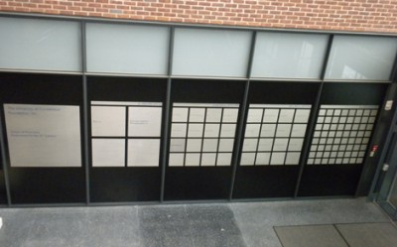**Lower Atrium**

This main entrance to the building is an open, three-story glass atrium between two sets of doors.  The area is to the left of the elevators and is adjacent to the student lounge. The large sculpture hangs in this area. The atrium doors on the east side of the building open toward the Chemistry Building while the doors on the west side of the building open onto Auditorium Road.

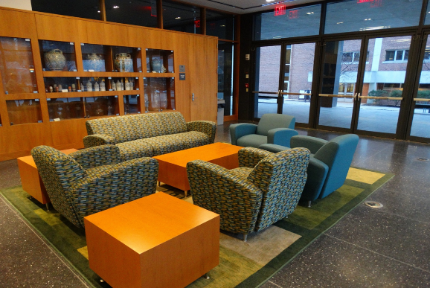**Joseph A. Morosko Student Lounge**

The student lounge is located on the first floor, adjacent to the lower atrium, and directly outside the Oscar & Julia Roth Classroom (131), the Milton & Rose Kalmanowitz Classroom (129) and the Gerard A. Weitzman Student Lunch Room.  Doors from the student lounge open onto the Arrow Pharmacy Terrace. The student lounge area contains display space, lockers, and seating/meeting areas for student use.

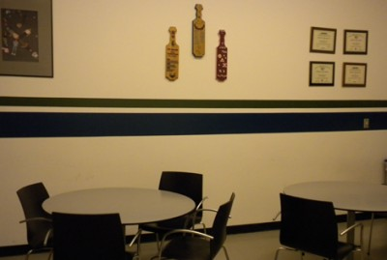**Gerard H. Weitzman Student Lunch Room**

The Weitzman Student Lunch Room (130) is equipped with a sink, refrigerator, microwave, counter space, and tables and chairs.  The student lunch room is located adjacent to the Joseph A. Morosko Student Lounge between the building’s two main classrooms.

**Arrow Pharmacy Terrace**

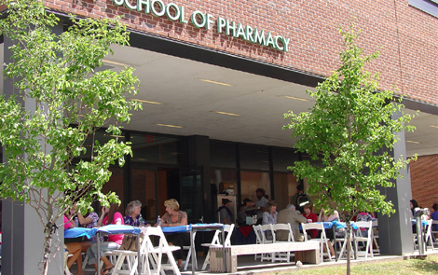The Arrow Pharmacy Terrace is located on the west side the building adjacent to the student lounge area, outside of the glass doors.  The flagstone terrace is covered and has benches located on the perimeter.

**Upper (4th Floor) Atrium**

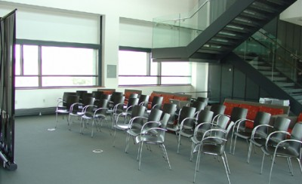The upper atrium, located on the fourth floor, provides additional seating/meeting space for students.

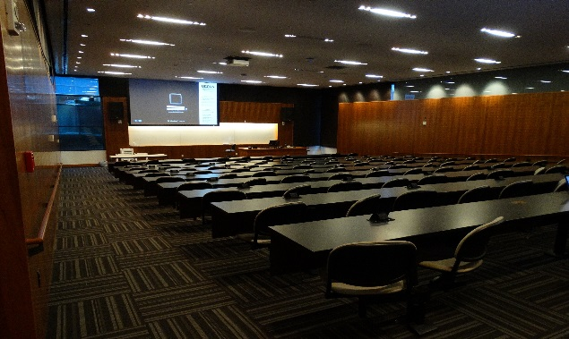**Classrooms**

The building has two main classrooms located on the first floor.  The **Oscar & Julia Roth Classroom** [PBB 131] is a sloped classroom with fixed seating and a work surface that includes power and a network connection so that students can use their laptops.  This high-tech classroom is equipped with state-of-the-art audiovisual equipment that allows broadcasting and viewing live seminars to/from off campus locations.

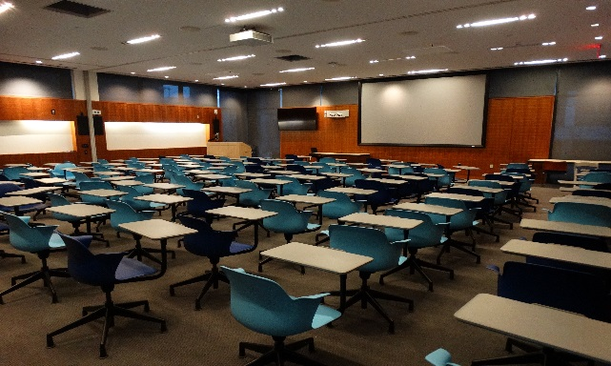The **Milton & Rose Kalmanowitz Classroom** [PBB 129] is a flexible space with desks that can be reconfigured.  The classroom is equipped with a moveable partition that allows the room to be divided into two separate classrooms for smaller class size instruction.  The room is also used for classes that require floor space such as CPR training.  High-tech equipment is located on both sides of the classroom.

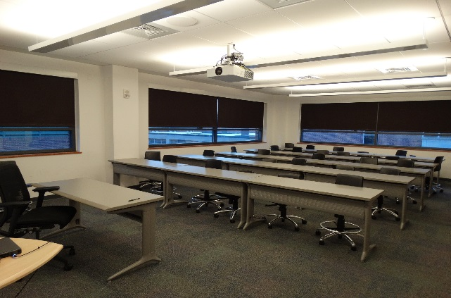

The **Classroom 338**, located on the third floor, is used for smaller classes, including graduate courses, and mid-sized meetings.  The classroom contains configurable tables and individual chairs to accommodate a theater-style and u-shaped arrangements.  A mounted projector and web access is provided for instructors.

**Teaching Laboratories**

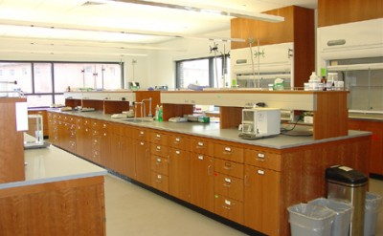The **Boehringer Ingelheim Pharmaceuticals, Inc. Dosage Forms Laboratory**, is a state-of-the-art facility where pharmacy students learn the latest techniques for compounding drug preparations that can be customized for individual patient needs.  It features stations for each student to prepare oral, topical, and other drug preparations; an area with laminar flow hoods where students practice techniques for preparing injectibles and sterile ophthalmic products; and containment rooms for tableting, coating, and emulsification equipment that provides students with an understanding of the processes used by manufacturers to prepare dosage forms on a large scale.

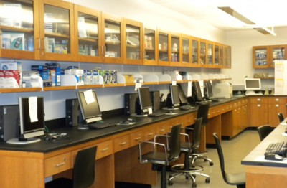The **CVS Pharmacist Care Center** is a multipurpose laboratory facility, with videotaping and presentation technology throughout.  It features networked computer workstations, small counseling rooms, and a classroom area.  Pharmacy students learn drug information and patient counseling techniques.  Prominent display cabinets house historical and contemporary drug product inventory.  The Pharmacist Care Center is also used to teach prescription processing and the proper techniques for administration of medication.

**Research Laboratories**

The north side of the building contains six floors of research laboratories. The first three floors are primarily biology laboratories. 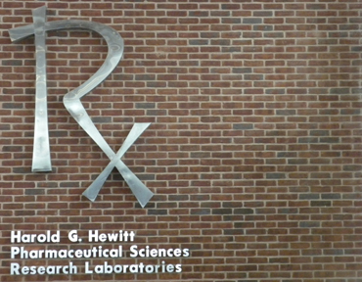The **Harold G. Hewitt Pharmaceutical Sciences Research Laboratories** are located in the north wing of the building on the fourth, fifth, and sixth floors. Medicinal chemistry, pharmaceutics, and pharmacology/toxicology research is conducted in laboratories customized for the specialized requirements of each researcher. Most laboratories also contain specialized chemicals necessary for research. The laboratory wing contains multiple autoclaves, numerous tissue culture facilities, state-of-the-art hooding and ventilation systems, and freeze-drying capabilities.  A [Nuclear Magnetic Resonance Facility](http://www.biotech.uconn.edu/nmrf/) and a [Protein X-Ray Crystallography Facility](http://www.biotech.uconn.edu/xrf/) are located in the basement of the building’s south wing.

### Conference Rooms

The School of Pharmacy has six conference rooms.  Three meeting rooms, one exclusive to pharmacy student organizations, one for the Department of Pharmacy Practice, and one for the dean, are located on the third floor of the building.  Department of Pharmaceutical Sciences conference rooms are located on the fourth, fifth, and sixth floors of the building.  In addition, an interview room is located adjacent to the reception area.

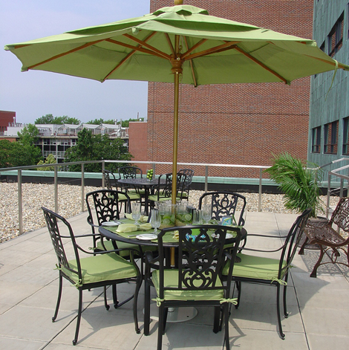The **Faucette Family Terrace** is a roof-top terrace that can only be accessed through the conference room on the fourth floor. It is located on the building’s west side above the third floor office wing.

### Pharmacy Library

### http://pharmacy.uconn.edu/wp-content/uploads/building-library-400x243.jpgThe Pharmacy Library supports the information and research needs of the students, faculty, staff, and alumni of the School of Pharmacy.  Access to the collections and services of the Pharmacy Library is available to the university community and other library users. The library seating area has individual study lamps and workstations offering network connections and power for laptops.

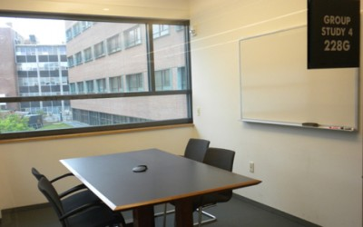There are four group study rooms located in the library; all are equipped with data and power. These provide a meeting place for pharmacy students to work on group assignments while still having immediate access to reference materials. The only access to these rooms is from the Pharmacy Library.

The **Hait Family Room**, located inside the library, provides a venue for the pharmacy students to master professional, technological, and research skills by providing access to the internet and to specific course related software as requested. Classes are sometimes held in this space.

**AED Devices**

Automatic External Defibrillators (AEDs) are located on the second and fourth floors of the Pharmacy-Biology Building near the central elevator banks. They are clearly marked with a sign that says, “AED.” AED boxes contain local alarms but do not automatically dial 911.

**Fire Alarm**

Alarms in academic buildings are activations – NOT drills. When an alarm is activated, you should exit the building in a calm and orderly fashion. If you are at the center of the emergency and call 911, expect to be asked the following types of questions:

* Where is the emergency?   
  Answer example: “Pharmacy- Biology Building Lab 499” or “Pharmacy- Biology Building in the Morosko Student Lounge on the first floor.”
* What is the emergency?  
  Answer example: “A 250 ml beaker of the chemical “reallytoxica” was spilled in Lab 499” or “A student has collapsed for no apparent reason.”

What you should do…

* Stay on the phone with 911.
* Follow the instructions of the 911 dispatcher.
* Stay at the scene if it is same for you to do so.

Please familiarize yourself with the school’s Emergency Action Plan.