Patient Safety: Drug Induced Cardiovascular Disease
At the conclusion of this lecture the successful learner will be able to:
- Identify heart block
- Differentiate between 1st, type-1 2nd, type-2 2nd, and 3rd degree AV block
- Describe the drugs and dietary supplements that can cause heart block and what to do if drug induced heart block occurs acutely and chronically
- Identify QTc interval prolongation and describe how much of an elevation dramatically enhances the risk of Torsade de Pointes
- Describe drugs and dietary supplements that may prolong QTc interval and interventions for acute Torsade de Pointes or chronic QTc interval prolongation
- Apply knowledge to a patient relevant case

- Using the rhythm strip below, what is the PP interval and the RR interval in seconds?
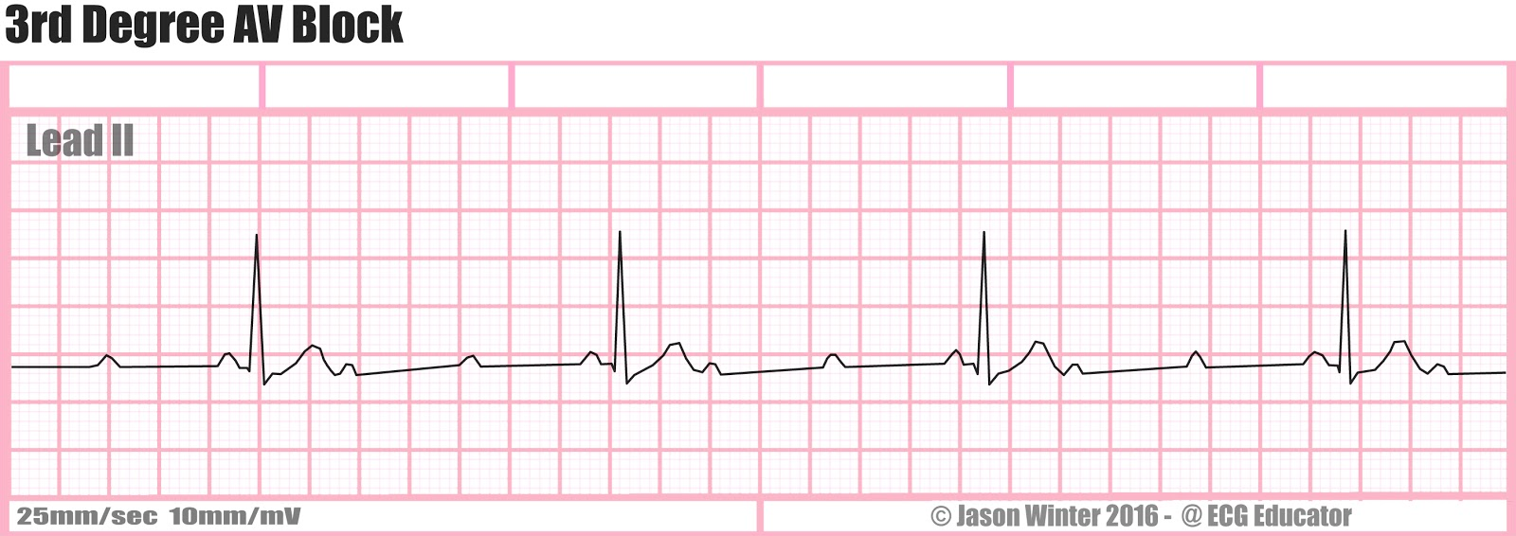
- PP interval = 0.52 s, RR interval = 1.44 s
- PP interval = 1.44 s, RR interval = 0.52 s
- PP interval = 0.73 s, RR interval = 0.73 s

- What arrhythmia is shown on this rhythm strip?
- First degree AV block
- Third degree AV block
- Torsade de Pointes

- Which of the following rhythm issues is unlikely to be induced by a drug that blocks the AV node?
- First degree AV block
- Type I second degree AV block
- Type II second degree AV block

- Which of the following drugs is least likely to cause drug induced AV block
- Amlodipine
- Metoprolol
- Digoxin
- If a patient has symptomatic heart block due to the use of drugs that can induce heart block, which of the following can be used to treat it?
- Gabapentin
- Propranolol
- Atropine
- Using the rhythm strip below, what is the QT interval, RR interval, and QTc interval in seconds?
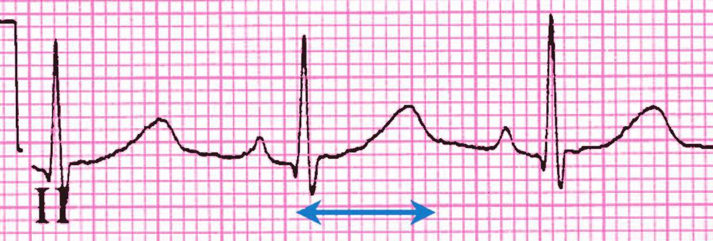
- QT interval = 0.66, RR interval = 0.85, QTc interval = 0.575
- QT interval = 0.44, RR interval = 0.76, QTc interval = 0.555
- QT interval = 0.44, RR interval = 0.76, QTc interval = 0.505

- Given the QTC interval above 500msec, what arrhythmia is the patient at risk of developing?
- Torsade de Pointes
- Pheochromocytoma
- Type II second degree AV block

- Which of the following drugs would be unlikely to cause QTc interval prolongation?
- Quinidine
- Sotalol
- Verapamil

- Which of the following drugs can treat patients with Torsade de Pointes?
- Magnesium sulfate
- Amiodarone
- Adalimumab

- If a patient is taking sotalol and his renal function markedly decreases, what is likely to happen to the QTc interval?
- It would get longer
- It would get shorter
- It would stay the same

